

**Value for Money**

**Annual Report**

**2022**

**Contents**

**Introduction 1**

**The North Star Approach to Value for Money 2**

**Value for Money Activity during 2021/22 7**

**North Star in comparison to other Housing Associations 18**

**2022/23 and Beyond 27**

**1.** **Introduction**

**Current Context**

Value for Money (VFM) has never been more critical for North Star and our customers.

Our customers are facing a cost of living crisis driven by a range of external factors. This comes after a two year pandemic which had already pushed many families into poverty and destitution. It is critical that North Star is able to deliver VFM so we are able to invest in our properties and further services for our customers

Many of the issues faced by our customers have an impact on North Star and we need to be proactive in addressing these challenges to ensure that we remain financially strong and able to invest in services and support.

There is a wide range of information on VFM in this report covering costs, performance and outcomes. There is data showing the trends within North Star and also compares North Star with our peers. The report also highlights areas of high cost or under performance along with actions to improve or provide further context.

Some more detail about each section is set out below:

**The North Star Approach** – this sets out the aims of the VFM strategy, a high-level view of the regulatory requirements and how VFM is embedded within North Star.

**Value for Money Activity 2021/22** - this section provides details of the key activity during 2021/22.

**North Star in Comparison to Other Housing Associations** – this section compares North Star costs and performance to peers. The main source of benchmarking data is HouseMark but it also uses data from the Regulator of Social Housing and Institute of Customer Service.

**2022/23 and Beyond** – this sets out the VFM actions for 2022/23

**2. The North Star Approach to “Value for Money”**

**2.1 Our Approach**

The Board approved the Value for Money (VFM) strategy in July 2021.

VFM is a constant for North Star. It is about doing more with our resources so that we can achieve our corporate objectives. By optimising VFM throughout the Organisation, we release additional resources to invest in services to tenants, maintain our existing homes and increase the supply of new homes.

Delivering this is part of an integrated and embedded approach, rather than something that is separate or an annual task that must be completed. It is a critical business tool. VFM at North Star is not just about reducing costs. Quality and cost are both important, as is the relationship between investment and performance, and these form the basis of our measurement and monitoring.

In summary, what VFM means to us includes:

* Economy, efficiencies and cost savings.
* Effectiveness and enhanced quality for tenants.
* Investment in new housing and existing homes.
* Added social value.

Our comprehensive approach is not new, but it has been progressively honed over the years. Our focus on continuous improvement has enabled us to develop and invest in keeping North Star strong.

The Regulator of Social Housing (RSH) has specific expectations of housing associations in relation to VFM which are set out in the April 2018 VFM Standard. Our VFM strategy enables us to express how we achieve these RSH expectations.

**2.2 RSH VFM Standard**

The RSH VFM Standard was issued in April 2018 and sets very clear expectations. The Standard can be viewed [here.](https://assets.publishing.service.gov.uk/government/uploads/system/uploads/attachment_data/file/919929/VfM_Standard_April_2018.pdf)

At the heart of the Standard is a requirement for Board to own and understand the VFM approach within their organisation. The specific requirements of the standard are:

Registered Providers **must**:

* Clearly articulate their strategic objectives.
* Have an agreed approach to achieving VFM in meeting these objectives and demonstrate their delivery of value for money to stakeholders.
* Through their strategic objectives articulate their strategy for delivering homes that meet a range of needs.
* Ensure that optimal benefit is derived from resources and assets and optimise economy, efficiency and effectiveness in the delivery of their strategic objectives.

Registered providers must **demonstrate**:

* A robust approach to achieving VFM.
* Regular and appropriate consideration of potential VFM gains. This must include full consideration of costs and benefits of alternative commercial, organisational and delivery structures.
* Consideration of VFM across their whole business, including their approach to investment in non-social housing activity.
* That they have appropriate targets in place for measuring performance in achieving VFM.

Registered providers must **publish** evidence in their accounts to enable stakeholders to understand:

* Performance against its own targets and any metrics set out by the regulator, and how that performance compares to peers.
* Measurable plans to address any areas of underperformance.

This report provides Board with a summary of the VFM activity across North Star and will also be used to create the statement that will be included in the 2021/22 Financial statements.

**2.3 Corporate Strategy to 2023**

A sustained focus on VFM is essential if we are to achieve our strategic objectives. To quote from the vision to 2023: *“achieving value for money is a constant for the business; not only is it a regulatory necessity, it underpins the health of the business. We are committed to an ambitious vision that requires us to find the resource and capacity to achieve this, and to provide value for money to our tenants. Balancing all of these priorities is challenging and essential”.*  Within the vision are the following corporate objectives that contain VFM:

1. **Growth**

We intend to gain strength through ambitious growth in the development of new homes and the delivery of services to others. We will increase the number of homes that we own and manage by at least 500 by the end of 2023.

1. **Culture**

We will continuously develop and maintain our relational culture whilst experimenting with new ideas and approaches. We will be inclusive, strong and bold and live and breathe our embedded values. Our culture will keep North Star strong.

1. **Customers**

We will co-design and shape outstanding services with our customers that work for the individual. Our customer base will be even more diverse and will include those who previously may not have considered North Star as an option. We will invest in communities to help transform lives.

1. **Partnerships**

We will invest in relationships and have strong partnerships that are business critical and bring value to North Star.

1. **Resources**

Strong resource management will be the engine that drives forward North Star’s vision. We will constantly seek out ways of resourcing activities and will be at the forefront of new thinking. Our focus on people, value for money and performance will strengthen our cost base and create additional resource.

**6. Technology and Digitisation**

We will operate out of a futurist mind-set and be alive to new technologies that keep us ahead of the curve. Over 60% of our customers will access our services digitally.

**7. Governance**

The Board will continue to pre-empt and respond to a constantly complex and changing world. This will keep North Star strong.

**2.4 Board, Customers and Staff**

Board

Board approved the strategy and lead and drive VFM across the business.

Assurance is provided to Board through regular and reports and metrics that include:

* Quarterly performance, finance and development reports with reports including benchmarking data where relevant. The finance reports also include a selection of the RSH VFM metrics.
* Annual Business Plan (April 2021) – this contained a section on the VFM metrics as well as a range of financial information for future years.
* Annual Update (July 2021) – this shares a range of VFM information including benchmarking date from HouseMark on costs, performance and on the delivery of economy, efficiency and effectiveness.

VFM also drives discussions on a range of topics including the business plan, corporate plan, the annual rent increase and our development plans for new units.

Customers

The insight, experience and challenge of our customers supports North Star to achieve its value for money objectives. Specifically involving customers enables us to:

* Improve efficiency, acting on feedback relating to the quality and performance of our services to drive improvements.
* Achieve greater value from our supply chain, informing procurement of services delivered to customers.

We have a range of opportunities for customers to challenge and influence North Star. The following groups are in place which have specific links to our work on value for money:

* Tenant Voice Scrutiny Panel (TVSP) – review performance against our customer commitments and present findings to our Board.
* Consumer Standards Group – test North Star’s performance against the Regulator of Social Housing consumer standards.
* Performance group – meet quarterly to scrutinise operational performance of North Star.
* Tenant advisors – participate in procurement exercises to ensure customers influence decision making and value for money.

During 2021/22 customers have:

* TVSP reviewed customer access to information. Recommendations were presented to Board in December 2021 and have been incorporated into an improvement plan. This included a recommendation to introduce a two way text messaging platform which has been successfully incorporated.
* Reviewed North Star compliance with the RSH Tenant Involvement and Empowerment Standard making recommendations for further improvement.
* Identified a new provider of catering services in our older person scheme Aspen Gardens. Customers helped design the scope and were involved in the procurement process, identifying the new provider.
* Completed policy reviews of our neighbourhood management policy and repairs and maintenance policy resulting in change to our approaches.
* Participated in the functional reviews of North Star housing and welfare benefit services, resulting in recommendation to pilot a new tenancy support role to focus on tenancy sustainment.
* Reviewed our approach to complaints and contributed to the design of our training on complaints for staff.
* Provided feedback and views on our current repairs service to inform the procurement of a new repairs service for North Star, to commence in September 2022.

**Leadership**

Our approach to leadership was developed in response to operating in an increasingly complex environment and, the need to ensure that our people remained healthy, resilient, and well. The external world continues to change at a breath-taking pace; uncertainty is a given, there are many unknowns, more complex questions, and a need to do things differently.

We have developed people to be involved, included, influential, leaderful, and accountable. Leaders are developed across the organisation and many people are involved in decision making. Skills are applied flexibly, and everyone engages with development and training. As a result, they have developed high levels of trust.

The investment in leadership helped to keep us strong and resilient during the Global Pandemic. Staff responded with speed, agility, and creativity. They could manage high levels of ambiguity, maintain their resilience, and adapt quickly to completely new ways of working. They remained committed to delivering great services and maintained performance across the organisation.

We have held Investors in People Platinum (held by only 3% of accredited companies) since 2017 and are accredited to 2023. As one of the highest ranked organisations in this category, we were invited to enter the UK IIP Platinum Employer of the Year award and went on to win. In an employee’s recruitment market, where competition for good staff is high, this is a very helpful award. It differentiates us from all other local Housing Associations.

Investing in the development of individuals and teams is a constant and is in addition to annual training, academic and professional qualifications. Our strategic priorities will ensure that the unique culture continues to develop.

The world continues to be a Brittle, Anxious, Non-Linear and at times Incomprehensible (BANI) environment, where there is often no blueprint or easy, clear answers. This requires everyone to continue to develop more of the skills required for the future. This will ensure that staff continue to work confidently and resiliently. During 2021, a Leadership Development Programme has supported Managers to further develop their skills, relationships, creativity and thinking. This will help will shape the next iteration of leadership which will be embedded further into the organisation through on going staff development.

Staff have led on various VFM approaches and initiatives embedded VFM in a number of ways:

* Developing business cases for new posts/replacements. This ensured that vacant roles were not automatically recruited and helped deliver savings of **£150k**.
* Reviewed our software licencing arrangements and made changes that resulted in savings of over **£10k.**
* A robust and challenging budgeting and reforecasting process. This helped reallocate budgets to help offset the pressure on repairs spend as a result of the recent storms.
* Creating business cases to support additional investment in key services and activities. During the year business cases were approved for a restructure of the IT team, the development of chatbot for the website and the use of Microsoft Intune on mobile devices. Along with additional staff resources being allocated for property compliance activity.

**3.** **VFM Activity During 2021/22**

This section includes:

* The overall financial performance of North Star.
* Year-end performance against VFM targets.
* The savings, efficiencies and reinvestments delivered.
* A summary of the social value and asset management activity in relation to VFM.
* Measures of effectiveness including customer satisfaction and performance.

**Financial Outturn 2021/22**



The table excludes exceptional items relating to the office refurbishment in 2017/18 and 2018/19 and the refinancing project in 2020/21.

The rent decrease impacted the operating margin in the period 2017-2020 but North Star remained ahead of our peers on operating and net margin. The operating margin has remained around 28% for the last four financial years despite investment being made in health and safety and improved services for customers.

**How each £1 of rent was spent during 2021/22**

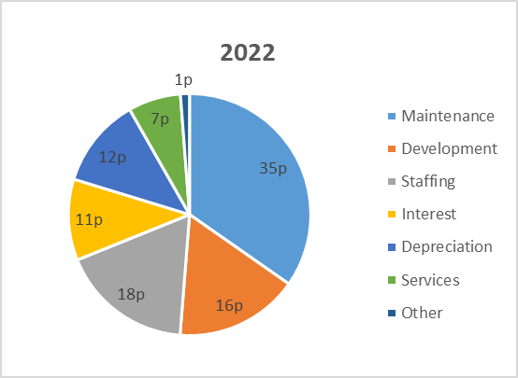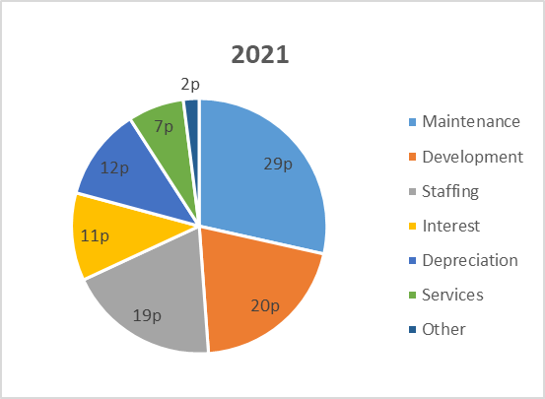

The most significant changes between 2021 and 2022 are:

* Increased investment on maintenance of £1.6m. Most of this increase is on our Decent Homes spend and this is driven by high quality stock condition data. We also started on energy efficiency works in a drive to get our properties to EPC C by 2028 – both strategic investment decisions. Revenue maintenance costs have also increased with more responsive repairs in the year primarily due to storm damage and catch-up repairs from reduced demand during the pandemic.
* Reduced investment in on development of £0.7m with a number of challenges impacting this including, delays following the lockdown on schemes, increased competition for sites, higher prices for land, shortage of contractors and delays in obtaining materials. These challenges were reported to Board during the year, and we are forecasting to increase development spend in 2022/23 and deliver over 80 new units.

**Performance against Targets**

The actions and targets were set in the annual corporate plan for 2021/22 and the VFM update shared with Board in July 2021. The outcomes marked in green have been completed, those in orange have been delayed and those in red the target was not met in 2021/22.

|  |  |  |  |
| --- | --- | --- | --- |
| **Strategic Objective** | **Action** | **Target** | **21/22 Outcome** |
| Customers | Implement real-time customer feedback. | Introduce Rant & Rave platform to capture and analyse customer feedback. Return on investment completed August 2021. | Platform implemented and system is live. Demo delivered to Board Members in October 2021. |
| Customers | Review the supported housing vision | Review will be used to inform continued growth of supported housing | Review completed |
| Customers | Review priority communities to invest in those most impacted by the pandemic | Review will inform the community investments made in 2021/22 and future years | Review has been completed and recommendations are being utilised by the Communities team to make investments and develop new partnerships. |
| Customers | Review customer satisfaction with ‘quality of their home’ and ‘rent providing VFM’ | New approach for rent and service charge setting to be used for 2022/23 charges.  Report to Board (from TVSP) on the customer commitment review | We have simplified how we communicate with tenants on the annual rent increase and shared the context in which decisions are made. Letters include a link to video messages from the CEO and Executive Directors reinforcing the rationale for the increase. We also provided more information on service charges  TVSP shared its report with Board in December 2021.  We used feedback and data from customers as part of our repairs review and this was used to create the specification for the procurement of our new repairs contractor. |
| Growth | Develop 50 new homes including 5 supported housing | 50 new units by 31st March 2022 | 32 new units delivered. |
| Growth | Review the sustainability of our stock in Gresham | Report to be shared with Board in September 2021 | Report shared with Board at September 2021 meeting. and agreed to continue to operate in this challenging area, however, to keep under review. |
| Growth | Secure external funding for retrofit works | Target to get grant income of £60k (10% of total budgeted spend on retrofit) | £380k has been secured for works to be delivered in the 2022/23 financial year. |
| Culture | Develop an EnviromentalStrategy | Strategy to be shared with Board in January 2022 | Update provided to Board in January 2022 and final strategy to be approved by June 2022 Board meeting. |
| Resources | Deliver procurement savings | £45k target included in the 2021/22 budget | Savings of £73k achieved |
| Resource**s** | Deliver savings through vacant posts | £80k target included in the 2021/22 budget | Savings of £150k achieved |
| Resources | Develop a Decent Homes Standard for our existing properties (in accordance with the Government timelines for review) | Approach to be shared with Board as part of Asset Management Strategy in June 2022 | There has been a delay in the new guidelines so this action will be completed during 22/23 once information is available. |
| Resources | Review the high number of repairs per property to understand any root causes | Report and action plan to be shared with SMT by December 2021 | Review carried out and was used to help inform the procurement process for a new repair's contractor. |
| Resources | Improve our tenancy sustainment and reduce our tenancy turnover | Target to reduce tenancy turnover KPI to under 10% | Tenancy turnover of 10.1% for 2021/22 |
| Resources | Review of the repairs service | Review will be used to inform future procurement of repairs service | Review complete and used to inform procurement of new repairs contractor in the summer of 2022. |
| Technology | Delivery of the first year of the ICT strategy:   * Integration of Office 365 including Power BI for reporting * Support the Paper Scarce project with the digitisation of back office processes * Implement a new telephony solution | * Use of Power BI for performance reporting to Board and within in the business * Continued reduction in paper use. Target to reduce by 25% * Transition to digital telephony platform | Office 365 now used by all staff  Power BI project now part of wider data project and implementation of new performance reporting scheduled for 2022/23.  Paper use reduced by over 30% in 2021/22.  New Teams telephony introduced in the year. |

Areas outside of target are:

New Units developed

There has been supply chain issues resulting in a twelve-week delay in receiving materials to finish our 22 properties at Middlehaven, Middlesbrough. This means we only completed 32 units (including six units of supported housing) in the year. We anticipate the final 22 will be completed in Q2 2022/23. We are forecasting unit growth of 80 units in 2022/23.

Tenancy Turnover

Tenancy turnover was sustained at just over 10% which was 0.1% higher than the target set. Relet performance and void loss were both inside target. During the year staff and tenants reviewed the housing and welfare benefit services to focus on tenancy sustainment and reduce turnover. A new tenancy support role focused on this will be trialled in 2022/23.

**2021/22 Savings Delivered**

The delivery of savings was key in both the 2021/22 budget and the 30-year business plan. The budget included a savings target of £130k with details below of how we performed. Progress is monitored during the year with a robust reforecasting process and month end management accounts.

Some of the key savings made in 2021/22 are captured below:

|  |  |
| --- | --- |
| **Saving** | **Value** |
| Vacant posts were held whilst we reviewed roles and functions. | **£150k** |
| Procurement savings on a range of new contracts | **£73k** |
| In 2021 we procured a new utilities provider with a fixed price till 2024 – this has protected North Star and our customers who pay service charges from the rising energy costs | **£25k** |
| We continue to benefit from the investment into the development of staff who can facilitate organisational and people development, reducing the need for external consultants. | **£26k** |

**2021/22 Reinvestment Activities**

Strong financial management enables us to outperform the budget. As a result, there have been a number of reinvestments made during 2021/22:

* Spend of **£75k** in 2021/22 on fire door surveys was approved by Board in June 2021. A further **£500k** was approved for inclusion in capital budgets for any remedial works required as a result of the surveys. This work will be complete in 2022/23.
* The reforecasting process resulted in a reallocation of the budget to support the pressure on responsive repairs spend as a result of the storms – the repairs budget was increased by over **£200k** with savings made in other areas of the organisation.
* Additional funding for community investment Our investment increased from an average of £250k for the last three years to just over **£290k** in 2021/22.

**2021/22 Efficiencies**

These are improvements or changes which may not directly impact or reduce costs but do free up staff time or resources. This report highlights a range of areas where the changes to a process or new ways of working will have delivered efficiencies meaning that staff can focus on providing additional support or services to customers:

* The piloting of a remote temperature monitoring system for water safety – removing the need for staff to carry out weekly tests
* Introduced a two-way text messaging platform following TVSP review on access to information and communication
* Implemented real time feedback, increased volume by 70%, reduced informal complaints by 25% and deliver 24 hour call back to customers
* Continued use of new ways of working such as virtual viewing on voids and digital sign up for new tenants
* Continued use of virtual and hybrid meetings by staff and Board members to reduce travel costs reducing travel costs by over £10k

**Community Investment and Generating Social Value**

North Star cares about its customers and communities. We focus our community investment on priority neighbourhoods working with the strengths and supporting the sustainability of these areas.

Teesside has the second greatest poverty rate in Britain, this increased through the pandemic with 69% of children in some wards in Middlesbrough living in poverty. The impact of the cost-of-living crisis, is already being felt acutely in the communities we work in.

In this context it is a key strategic choice to invest in our communities, working with people to address community challenges and improve the quality of their lives. During the last year this has included:

* Funding community grocers’ shops in Thornaby, Hartlepool and Middlesbrough to provide a sustainable solution to food poverty.
* Supporting a community action group in rural Teesdale to expand. The group provided emergency relief to people in their community following the power cuts resulting from storm Arwen. The work with the group has also resulted in a member gaining full time employment as a youth worker with Teesdale YMCA.
* Funding a forest school project in Teesdale that tackles social isolation in older people by providing them with opportunities to be creative in nature.
* Providing activities for children and young people during school holiday breaks. These activities have supported families on low income to make food budgets go further and reduced the cost of keeping children entertained.
* Supporting community growing projects across Stockton to use public space to grow fruit and vegetables that are free for residents to use.

By investing in such projects, services and activity we generate social value. We measure and [report](https://www.northstarhg.co.uk/about-north-star/corporate-information/social-value-reports/) the social value created using a suite of treasury approved measures combining qualitative and quantitative outcomes.  In 2021/22 North Star has delivered approximately £4m of social value across our business.  This figure is made up of:

* £3m generated by community investment projects.*
* £250k generated by tenant connection activity.*
* £600k generated by planned maintenance activity*.
* £300k generated by positive move on from supported accommodation*

*estimated figure based on previous year’s performance excluding Covid-19 relief work.

**Asset Management**

Our property portfolio is diverse. Our Asset Management Strategy (approved by Board in June 2022) sets out how we manage, maintain, and review the performance of our stock. We hold stock condition data on over 99% of our assets and get a sampleour stock condition surveys externaly validated every two years – this was last shared with Board in March 2021. This robust data helps to inform our strategic decisions relating to stock investment. Our investment programme is developed to combine works to both minimise disruption for customers and achieve efficiencies for North Star through procurement.

During 21/22 we invested £3,479k with a focus on energy and environmental works, electrical and heating upgrades, as well as a large external works programme. In total 955 homes benefited from investment work, with customer satisfaction at 94%. Active asset management and planned investment is not only vital to ensuring homes meet customer expectations, it is also key to reducing responsive repairs.

We commenced our decarbonisation investment during 2021/22, with the aim for all stock to achieve EPC level C by 2028 and for stock to be decarbonised by 2050. We were successful in securing **£380k** through Wave 1 of the Social Housing Decarbonisation Fund and have commenced a programme of insulation works to our properties and installing Air Source Heat Pumps to replace some of our solid fuel heated properties. We hold energy performance information on 1,500 (c40%) of our housing stock and have used this as a baseline for our modelling with support from external consultants. Over the forthcoming year we will continue to enhance our knowledge of the energy performance of our stock and aim to maximise our investment by accessing grant subsidy and to work collaboratively with Local Authorities and peers to achieve efficiencies for North Star through joint research and procurement.

Return on Assets

Our asset management model is based on reviewing the Net Present Value (NPV) for asset groups and individual properties. We use this data to understand more about the financial performance of our stock, and as a tool to help us maximise the efficiency of the stock when making asset management decisions. We refresh this annually and review the top and bottom performing asset groups. We identify actions to enhance financial performance where possible and/or help sustain our stock and estates moving forward. Recent examples of our approach have included:

* Conversion of two bed sits in Barnard Castle into a 2 bedroom house.
* Reviewed sustainability issues with our stock in Gresham, Middlesbrough, with a report shared with Board in September 2021.

Our Neighbourhoods

In addition to evaluating the financial performance of our stock, we also analyse the performance of our stock in the context of the neighbourhoods and communities we operate in. On an annual basis we refresh our neighbourhood sustainability matrix, which assesses the overall health of communities. Having a more detailed understanding of the value of our assets (financial, social and environmental) provides us with good and transparent data to help us support our strategic asset management decisions. A recent example of this is our review of the Gresham stock in Middlesbrough.

We work in some challenging communities which experience high levels of deprivation with socio economic problems. We are committed to these communities and see our investment as helping to sustain and enhance the areas and lives of our tenants and neighbourhoods. Investment will reflect local circumstances, with health and stability of communities playing a key role in our investment and management decisions.

Our Neighbourhood Sustainability Tool assesses the health of our communities following analysis of a range of socio economic indicators, including levels of anti-social behaviour (ASB), crime and housing demand. The following chart combines financial and neighbourhood sustainability data.

(2021: Q1-61%; Q2-36%; Q3-1%; Q4-4%)

Most of our stock is performing well financially, though the 2022 performance has been impacted by the higher number and value of repairs in the last year. We will continue to review our lower performing asset groups to understand more and look to improve the financial performance where possible.

**EFFECTIVENESS**

VFM is also about the effectiveness of the organisations as well as the economy and efficiency. The following demonstrates how we capture effectiveness of delivering our strategic objectives across North Star.

**Customers**

We capture customer satisfaction in two ways, through transactional surveys with customers after specific interactions and secondly through an annual survey focusing on customer’s perception of North Star.

**Customer Satisfaction**

We capture independently gathered satisfaction data covering a number of service areas. This is benchmarked against other housing providers using the HouseMark scheme. The performance is set out below including actions for key areas of underperformance:

|  |  |  |  |  |  |  |
| --- | --- | --- | --- | --- | --- | --- |
| **% of Customer Satisfaction with** | **2019/20** | **2020/21** | **Target**  **2021/22** | **2021/22** | **Proposed 2022/23 Target** | **HouseMark Quartile Position** |
| Planned investment work | 94.4% | 96% | 95% | 94% | 95% | Not available |
| New homes (new build) | 98.3% | 98.1% | 95% | 92% | 95% | Not available |
| Major adaptations work | 100% | 100% | 95% | 100% | 100% | Not available |
| Quality of the home | 87.8% | 84% | 90% | 88.4% | 90% | Upper |
| Maintenance service | 88.3% | 90% | 92% | 88.6% | 92% | Median |
| ASB management | 96% | 100% | 100% | 85% | 95% | Upper |
| Complaint management | 65.9% | 100% | 93% | 52.9% | 80% | Lower |
| Rent providing VFM | 94.4% | 92% | 95% | 96% | 95% | Upper |
| The overall service | 92.3% | 90% | 92% | 85.3% | 92% | Median |

It was disappointing that we missed the majority of our internal satisfaction targets. With the exception of complaints, we benchmark at median or upper level where data is available.

Satisfaction with planned investment works is 1% below target. Areas of dissatisfaction were primarily linked to kitchen and bathroom replacements and the disruption caused as a result material delays and the self-isolation of operatives. This has understandably led to some frustration for customers as the work has taken longer than anticipated. We have reviewed our communication to tenants so that there is clarity on what is to be expected during the works.

Satisfaction is slightly below target for our new build programme, with the primary reason being the difficulty in addressing defects in a timely manner due to material delays. We have reinforced requirements for addressing defects with our developer partners and reviewed our communication with tenants to manage expectation.

Customer satisfaction with the quality of home has increase by 4% when compared to 2020-21 but remains below target. We have analysed the feedback from customers who have expressed concerns with the quality of their home. Themes include draughts within the property, the level of sound proofing and length of time to complete repairs. All customers expressing dissatisfaction with their home have been contacted and have received an inspection from one of our surveyors to identify work required to improve the home.

We have had issues with our repairs contractor during the year and this has impacted two satisfaction metrics (maintenance and overall service). ESH Facilities our current repairs contractor, has faced challenges with labour resources, the reliability of sub-contractors, access to materials and high levels of turnover within administrative teams. These issues have led to inconsistent levels of service and spikes in the number of missed appointments and the length of time to complete repairs.

Despite these challenges, satisfaction remains at medium when compared to our HouseMark peer group. We are pleased to report that in March and April 2022 satisfaction has reached 92%. We are in the process of procuring a new contractor and customer feedback and complaints have been used to inform this process. The new repairs contractor will commence the new service on 1ST September 2022.

We experienced a reduction in satisfaction with our handling of anti-social behaviour (ASB), primarily as a result of the outcomes achieved as a result of their ASB complaint. During the year we experienced an increase in minor complaints and neighbour disputes reported. We have strengthened our partnership work with police and local authorities in tackling ASB and are providing further legal training to staff. Satisfaction remains upper quartile and the reduction in satisfaction will be subject to further review.

Satisfaction with complaint management has reduced and was below target. Following the publication of the Housing Ombudsman complaint handling code we reviewed our policy and procedure with tenants. This led to further training to staff and the introduction of a fast feedback service to make it easier for customers to tell us when things have gone wrong. We are carrying out a further review of complaints to understand the poor performance in this area.

Customers reported 96% satisfaction with rent providing value for money in 2021/22. Communication relating to the rent increase in 2022/23 was enhanced. This provided greater detail and transparency on how North Star spends income with a QR code link from the rent letter to connect customers to this information held on our website.

Satisfaction with the overall service is below target and 5% below satisfaction levels in 2020-21. The most common themes for dissatisfaction were the length of time to complete repairs and poor communication during the repairs process. The repair service has been reviewed with a new repair contractor to commence from 1st September 2022. Jobs being completed first time and communication with customers formed key parts of the service specification.

**Customer Perception**

Our membership of the Institute of Customer Service (ICS) enables access to leading edge research on the customer experience, connection with customer service innovators operating in a range of sectors and a non-housing sector benchmarking scheme, the [UK customer service index (UKCSI)](https://www.instituteofcustomerservice.com/product/ukcsi-jan-2021/).

Detailed research from ICS the shows a direct correlation between great customer service and the financial performance of an Organisation which can help drive VFM.

A periodic survey with the ICS enables North Star to assess the customer perception of the business. The latest survey was completed in May 2022. Headlines from this survey:

* North Star scored 83.6/100 which is top of the 50 housing associations in the ICS. This is comparable with the top 20 organisations operating nationally across a range of service sectors.
* Customers highlighted the ethics, customer experience and ethos of the organisation as strengths. The competence of staff and range of communication channels were identified as areas customers were most satisfied with.
* Customers identified complaints as an area North Star could improve. There was an improvement in the speed of handling complaints, but the outcome and attitude of staff were identified as areas for further improvement. We will undertake further analysis of these results and identify action to improve our complaints satisfaction.

**Performance**

Another measure of effectiveness is the KPI performance and the annual performance for 2021/22 was shared with Board in June 2022.

| **Performance Area** | **2019/20** | **2020/21** | **Target 2021/22** | **2021/22** | **Target 2022/23** | **HouseMark**  **Quartile Position** |
| --- | --- | --- | --- | --- | --- | --- |
| Current arrears – General Needs & Older Persons (GN&OP) | 2.29% | 2.50% | 2.3% | 2.54% | 2.5% | Median |
| Current arrears – Supported | 0.79% | 0.70% | 0.70% | 0.77% | 0.75% | Not available |
| % rent lost through homes being empty (GN&OP) | 0.85% | 1.02% | 1% | 0.89% | 1% | Upper |
| % rent lost through homes being empty (Supported) | 3.70% | 2.72% | 2.75% | 2.94% | 2.75% | Not available |
| Tenancy turnover rate | 12.9% | 12% | 10% | 10.1% | 9% | Lower |
| Average number of repairs per property | 3.6 | 3.8 | 3.7 | 3.9 | 3.4 | Lower |
| % of appointments kept | 91.3% | 95.8% | 95.0% | 93% | 96% | Lower |
| % of gas services completed before expiry date at quarter end | 99.9% | 100% | 100% | 99.8 % | 100% | Medium |
| % of time lost to sickness | 3.2% | 1.5% | 2.5% | 2.45%  2.16%* | 2% | Not available |

*Performance adjusted to removed impact of absence due to Covid

We set challenging performance targets informed by three-year trend data and consideration of our operating environment. We missed our performance targets in a number of areas and more information about these areas is set out below.

We missed the arrears targets for general needs by £37k and supported housing by £2k. During the year there was a 15% increase in customers claiming Universal Credit (UC). The relationship between UC and arrears is complex. Delays in payments, the value of UC payments being less generous than legacy benefits and payments being made directly to customers are some of the factors which can lead to increased arrears. As a result of the cost-of-living crisis, we anticipate continued pressure on household income which could also result in arrears rising in 2022/23. We have a strong performance focus on arrears and to support customers we have introduced an additional Tenancy Support resource. A £200k hardship fund has been created aimed at alleviating hardship for customers experiencing challenges, providing access to energy payments, mental health support, debt advice and furniture.

Our Welfare Benefit team supported 657 households to increase their income by £586k, of which £104k is direct gains to the rent accounts through back dated housing benefit and discretionary housing payments. This work benefits both customers and North Star.

Tenancy turnover was 10.1% and we performed strongly reducing the number of days to relet homes and the amount of rent lost through voids. We are introducing a new resource with the aim of improving tenancy sustainment and are targeting a further reduction in turnover.

The average number of repairs per property has increased due to the impact of storms during 2021/22 and some catch-up of repairs deferred during the lockdowns. We anticipate this returning to expected levels of 3.7 repairs per property but will keep this under close review.

The percentage of appointments kept has fallen due to operational issues with the repairs contractor – this has included a shortage of operatives due to Covid and supply chain issues impacting the materials needs for some repairs.

Our performance on gas servicing was due to our inability to gain access primarily due to self-isolation of tenants due to covid. Performance has now returned to 100% as of June 2022.

**4. North Star Trends and Comparison to other Housing Associations**

**Benchmarking**

Benchmarking enables us to assess costs and performance against our peers.

There is a time lag to the publication of benchmarking data so the most up to date peer information is for the 2020/21 financial year.

There is a range of information available which can be used to benchmark the performance and costs of North Star. It can identify areas of high cost or poor performance that can be investigated by staff and action taken to improve if required. There can be difficulties in drawing absolute comparisons on benchmarking data. We use benchmarking in the following ways:

**HouseMark**

HouseMark are the leading data and insight company for the UK housing sector. North Star pay an annual fee to be a member and also submit quarterly performance data and annual cost data. HouseMark also collate the Sector Scorecard data. The most recent peer group data is for the 2020/21 financial year.

**RSH Global Accounts**

Every year we are required to submit financial information to the RSH in the Financial Viability Assessment. All organisations with more than 1,000 units are required to submit this data. The RSH then publishes an annual paper along with the data for all organisations. The 2021 Global Accounts report can be viewed [here](https://www.gov.uk/government/publications/2021-global-accounts-of-private-registered-providers).

**RSH VFM Metrics**

As part of the RSH VFM standard organisations are required to publish a set of VFM metrics. This data is then shared for all organisations along with a report. The full report for the 2021 metrics can be viewed [here](https://www.gov.uk/government/publications/2021-global-accounts-of-private-registered-providers).

**Peer Groups**

Where possible the standard peer group as set out below has been used in the analysis. The standard peer group is taken from organisations in the North East, North West, Yorkshire and Humberside with between 2,500 and 7,500 units with supported housing. However, not all of this peer group submit data onto HouseMark and to ensure there is a sufficient sample size we have used a different peer group for the HouseMark analysis – details of this peer group are shared later in the report.

|  |  |
| --- | --- |
| North Star Housing Group | Leeds Federated HA Ltd |
| Broadacres HA Ltd | Mosscare St. Vincent’s Housing Group Ltd |
| Calico Homes Ltd | Muir Group HA Ltd |
| Community Gateway Association Ltd | South Lakes Housing |
| Connect HA Ltd | South Liverpool Homes Ltd |
| Equity Housing Group Ltd | South Yorkshire HA Ltd |
| Irwell Valley HA Ltd | Southway Housing Trust (Manchester) Ltd |
| ‘Johnnie’ Johnson Housing Trust Ltd | Weaver Vale Housing Trust Ltd |

**RSH VFM Metrics**

The tables below show the performance on the VFM metrics over the last four years and includes the draft figures for 2021/22.

There is no peer group data available yet for 2021/22.

**North Star Trend**

The key points to note from the North Star data are:

* The reinvestment metric has increased in 2022 with higher spend on planned maintenance – this was £2.9m in 2022 compared to an average of £1.6m in the previous three years. This was driven by our stock condition data and the need to replace components as they come to the end of their economic life, to meet our commitment to meeting Decent Home Standard.
* The new supply delivered metric has fallen to under 1% with delays to a number of schemes result in only 33 new units being delivered in the year.
* EBITDA MRI interest cover was back at over 202% having been impacted by the exit costs in the refinancing project in 2021.
* For the first time in the last five years there was a significant increase in the Headline Social Cost per Unit. The main factors that increased this metric were the level of capital planned maintenance and responsive maintenance spend. More detail on this metric is set out below.

**North Star v Peer Group Metrics**

The two areas where North Star is not performing as strongly as our peers are based on the 2022 data:

Reinvestment Metric

North Star are consistently lower than our peers for this metric which captures the level of capital spend on new development and existing properties. The table below shows that this is due to less capital spend on both new development and existing properties.



The investment in existing homes is driven by the stock condition data and Decent Homes Standard requirements. As per the 2022 Business plan the investment in existing home averages 1.5% over the next 10 years which is more in line with the peer performance and demonstrates the cyclical nature of this spend. It will also start to be impacted by the investment in decarbonisation and this could further increase the differences between organisations as the investment in decarbonisation spend will vary depending on the approach taken by each organisation.

Although North Star has lower spend on new units than our peers (see bottom row of above table) North Star still outperforms the peer group on the second RSH metric for percentage of new units delivered (see table on previous page).

HSCU

There is a specific section below with more detailed analysis on the HSCU for North Star and our peers.

**The Sector Score Card**

There are also a number of additional metrics that we record and report that are known as the Sector Score Card and these are collated by Housemark.

|  |  |  |  |  |  |  |  |
| --- | --- | --- | --- | --- | --- | --- | --- |
| **Indicator** | **2018/19**  **Actual** | **2019/20**  **Actual** | **2020/21**  **Actual** | **2021/22**  **Draft** | **NS**  **Trend** | **2020/21**  **Peer** | **Peer**  **Trend** |
| Units Developed | 63 | 65 | 72 | 33 |  | 62 |  |
| % respondents very/fairly satisfied with the service | 87.5% | 92.3% | 90.0% | 85.3% |  | 87% |  |
| £ invested in communities | £246k | £249k | £280k | £290k |  | £280k |  |
| Occupancy rate | 98.8% | 98.9% | 99.2% | 99.2% |  | 99.1% |  |
| Ratio of responsive repairs to planned maintenance | 0.50 | 0.49 | 0.51 | 0.55 |  | 0.82 |  |
| Rent collected % | 99.1% | 102.0% | 99.6% | 98.3% |  | 99.6% |  |
| Overheads as a % of adjusted turnover | 12.0% | 10.9% | 10.5% | 12.4% |  | 12.8% |  |

The number of units developed and customer satisfaction metrics have already been explained earlier in the report. The rent collected metric was impacted by the timing of housing benefit payments as 2021/22.

The overheads as a percentage of adjusted turnover have increased in 2021/22 – the previous two years were impacted by several one-off items that reduced overhead costs – this included a VAT refund in 2020/21. Despite the increase it remains lower than the peer median and remains a key area of focus for budget setting and reforecasting.

**HSCU ANALYSIS**

This section sets out some more detail on the Headline Social Cost per Unit (HSCU).

**HSCU Four Year Trend**

The graph below shows how the HSCU has changed for North Star over the last four years and also includes the draft HSCU analysis for 2021/22:

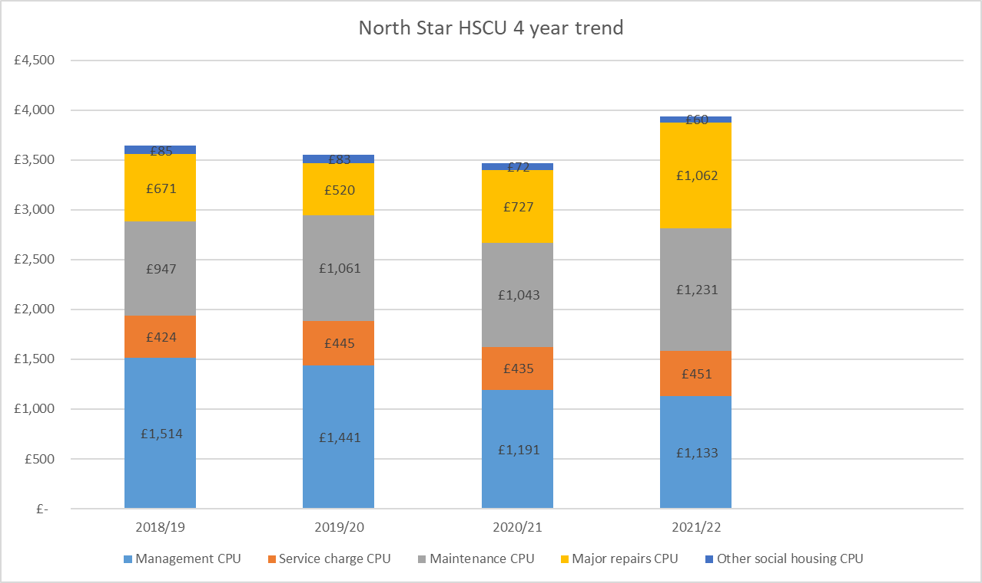

The most significant change in the last four year is in the 2021/22 HSCU which has increased to just under £4,000. This is due to higher levels of revenue and capital maintenance spend and this was explained at the start of section 3 of this report.

**HSCU North Star v Standard Peers 2020/21**



Although the HSCU is lower than our peers, our management CPU is higher. As the raw data is taken from the statutory accounts of Associations it is hard to drill down any further. Additionally, there is no sector wide approach to the allocation of costs, which makes absolute comparisons difficult. We have carried out further analysis into this by using HouseMark data (which is submitted using a standard approach) and this shows that management costs within North Star are comparable to our peers.

In the period from 2018 to 2021 the North Star HSUC changed from £3,506 to £3,449 which is a 2% reduction. This compares with an increase of 7% in the peer HSCU in the same period.

We anticipate that the HSCU will rise for North Star and our peers driven by the investment in health and safety maintenance works and decarbonisation. The HSCU will also be impacted by inflationary cost increases.

The high level nature of the HSCU means that it is hard to drill down to investigate the variances and any further analysis would need organisations to share more detailed financial information.

**HouseMark**

This section of the report focuses on the cost and performance data for the year to 31st March 2021 as data for the 2021/22 financial year is not yet available. Where possible performance data for 2021/22 has been shared to provide further context. The peer group used in this analysis is different to the standard peer group – it is made up of organisations with up to 5,000 units in the North East, North West, Yorkshire and Humberside. This is to ensure there is an adequate sample size to allow meaningful analysis.

There is a huge amount of cost and performance data within Housemark and in most areas North Star is at median or better. The next section highlights areas of performance where North Star is underperforming or is an outlier.

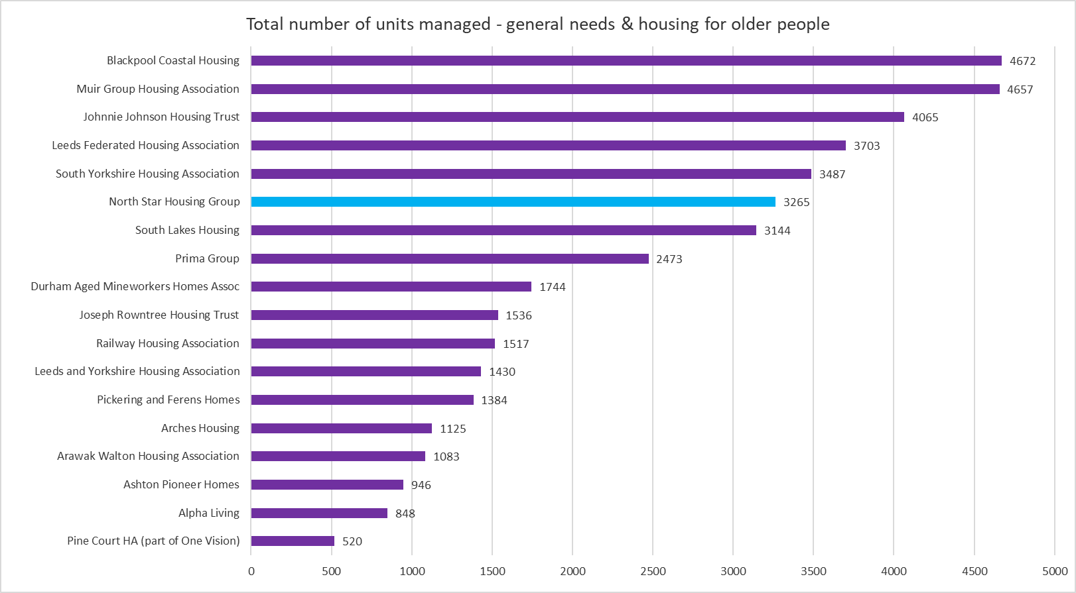

Housemark has a standard report called a VFM Quadrant – this uses a cost and performance metric in a number of service areas. TCPP stands for Total Cost Per Property.

|  |  |  |  |
| --- | --- | --- | --- |
| **Key** | **Service** | **Cost indicator** | **Performance indicator** |
| 1 | Responsive repairs | TCPP of responsive repairs (Service provision) | Satisfaction with the overall repairs service |
| 2 | Void repairs and lettings | TCPP of void repairs (Service provision) | Void loss % |
| 3 | Rent arrears & collection | TCPP of rent arrears & collection | Rent collected % |
| 4 | Tenancy Management | TCPP of tenancy management | Tenancy Turnover |
| 5 | Involvement | No data available | No data available |
| 6 | Customer services | TCPP of housing management | % of complaints responded to within target time |
| 7 | Neighbourhood management | TCPP of ASB | ASB Cases per 1,000 properties |
| 8 | Community investment | TCPP of community investment | Reinvestment |

The charts below show the North Star performance for the 2020/21 financial year and the arrows track the movement from the 2019/20 data: Black arrows show a negative direction of travel and white arrows are positive:

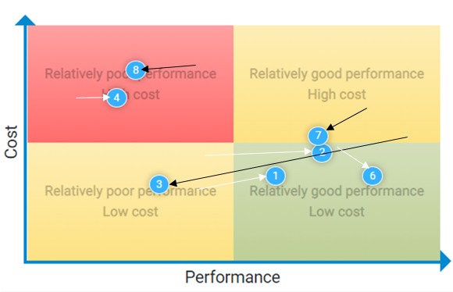

The movement for most areas is positive with costs reducing or performance improving. The areas where there has been a worsening are rent arrears and community investment. More detail is set out on these areas below.

**Areas of Underperformance**

1. **Tenancy Turnover**

North Star has been in the bottom quartile of this metric for a number of years. Despite North Star improving from a tenancy turnover of over 14% in 2018/19 North Star is still in the bottom quartile. The graph below shows that the peer bottom quartile has improved from just under 10% to less than 8%.

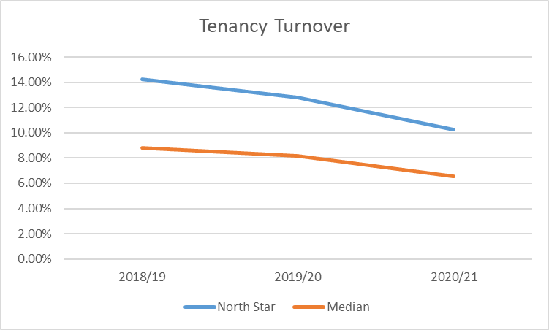

In 2021/22 tenancy turnover was 10.1% continuing a positive 3-year trend. We operate in challenging neighbourhoods which impact this measure. Our relet and void rent loss performance was strong in 2021/22. Given our operating environment we are targeting an incremental 1% improvement in performance with tenancy turnover. We have reviewed resources in our housing team and introduced a tenancy support role to support continued work to reduce tenancy turnover.

1. **Community Investment**

This is an area where Housemark show North Star in the fourth quartile and our spend is more than double the median level of our peer group. This reflects our strategic objective of supporting customers and communities as set out in our Surplus for Purpose statement. These costs include our Welfare Benefits staff, the Communities team and an apportionment of overhead costs. The Communities team are key to delivering the social value of £4m noted earlier in the report.

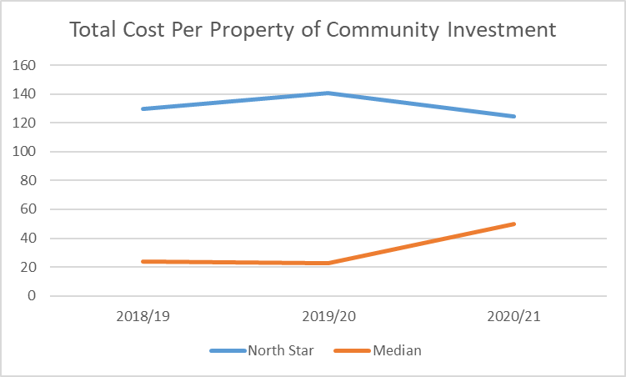

1. **Current tenant arrears**

Gross current tenant arrears increased in 2020/21 to 2.91% The data on Housemark is the gross arrears so include any Housing benefit debt – all other arrears figures shared with Board during the year are net arrears which excludes Housing benefit related arrears. The 2020/21 North Star figure has increased due to the timing of the Housing Benefit cycles for the local authorities we work with. There is a more positive trend and peer comparison on the net arrears.

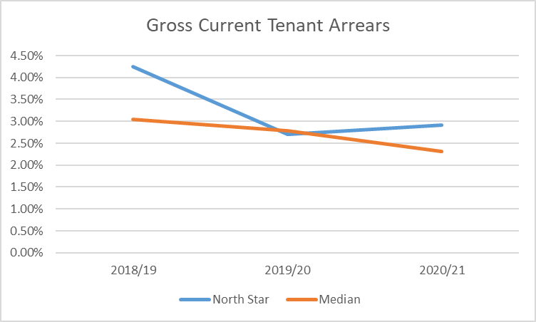

As at 31 March 2022 net arrears were at 2.54% - the available data for this period shows the sector median at 2.89% and the North East median at 2.80% for net arrears so North Star performance is above the median level.

There is a continued focus on reducing arrears and we know that this will become more challenging with the cost-of-living crisis faced by our customers.

**5.**  **2021/22 and Beyond**

VFM is at the heart of our corporate objectives, budgeting and business planning processes.

We are operating in an extremely challenging economic environment with high inflation impacting North Star, our supply chain and our customers. Rising interest rates, labour and material shortages and a potential recession all add to the financial pressures faced by North Star, our suppliers and our customers. Continuing to deliver VFM will be key to enable North Star to support our customers and communities whilst remaining financially strong and resilient.

Work is underway to set the next three year vision to 2026 and value for money will be a key part of this vision given the financial challenges faced by North Star and our Customers.

**2022/23 Value for Money Targets and Objectives**

The table below captures the Corporate Plan objectives approved by Board in March 2022. Following the analysis outlined in this report, further VFM Targets have been developed. Any items in blue are from the Corporate Plan.

**2022/23 Value for Money Targets and Objectives**

|  |  |  |  |
| --- | --- | --- | --- |
| **Strategic Objective** | **VFM Theme** | **Action** | **Target** |
| Customers | Efficiency | Pilot new online chatbot and promote online services to customers | Increase digital transactions > 20% and reduce CST call volume by 10% to improve efficiency and customer satisfaction. |
| Customers | Efficiency | Complete a review of key customer experiences to address customer need and improve effectiveness of delivery. | Reduce our customer effort score <3.5/10 (ICS)to improve efficiency and customer satisfaction. |
| Customers | Efficiency | Complete ICS customer survey UKCSI benchmark and implement actions for improvement areas | Survey completed and action plan developed |
| Customers | Efficiency | Review the capture and reporting of customer satisfaction | Processes and systems developed to report against the new Tenant Satisfaction Measures from Q1 2023. |
| Customers & Governance | Maximise Social Value & Efficiency | Explore and pilot ways of strengthening customer involvement at a strategic level through structures and/or systems | Method of involvement identified by September 2022 and piloted by December 2022. |
| Customers | Enable Growth | Develop a strategic offer to tackle homelessness | 6 new homes will be delivered to alleviate homelessness by Q4 |
| Customers | Enable Growth | Engage with Local Authority/ Health partners in Tees Valley and County Durham to develop a plan increase new supported housing | Bid to access the £300m funding available for new supported housing through the Social Care White Paper for 2022-25 |
| Customers | Efficiency | Continue to reduce tenancy turnover | Reduce tenancy turnover by 1% annually. 9% target for 2022/23 |
| Customers | Maximise Social Value | Ensure there is a process in place to capture outcomes from the £200k community fund set in the 2022/23 budget | Track spend and outcomes and include in update to Board at December 2022 meeting |
| Growth | Enable Growth | Develop and grow by at least 75 new units, including five units of supported housing | 75 units by March 2022. |
| Growth | Enable Growth & Active Asset Management | Explore models for the delivery of zero carbon new build homes | Produce costed model for our Future Homes Standard |
| Growth | Active Asset Management | Undertake a feasibility study into the transformation of terraced properties in Darlington | To develop a costed feasibility by Q2 |
| Growth | Active Asset Management | Deliver a decarbonisation pilot on a Victorian terrace property in Middlesbrough | Complete a whole house retrofit project to an EPC A standard. |
| Growth | Active Asset Management | Through targeted investment, increase the energy performance of properties to EPC level C | An additional 189 properties will reach EPC C by Q4 |
| Growth | Active Asset Management & Maximise Income | Bid for grant subsidy to support the decarbonisation of properties | Confirmation of grant funding of at least £200k by end of Q3 |
| Culture | Efficiency | Use internal resources to design and facilitate staff development | £25k efficiency |
| Resources | Efficiency | Review of recruitment and selection. Ensuring our approach is efficient, effective and meets the requirements of NS and Candidates | £20k efficiency |
| Resources & Technology | Efficiency | Deliver a data solution to replace the HR database. | £12k efficiency |
| Resources | Efficiency & Maximise income | Deliver savings target set in the 22/23 budget | Savings of at least £247k; void loss 1.35% and bad debt 1.04% |
| Resources | Maximise Social Value | Publish an Environmental, Social and Governance report for the 2021/22 financial year | Report published by end of Q2 |
| Resources | Efficiency & Maximise Income | Review of investment options for cash balances with Centrus | Return of at least 0.50% on invested funds |
| Resources | Smart Procurement & Efficiency | Implement a new repairs and voids service that will create efficiencies for NS and improve customer satisfaction | A new service to be in place by September 2022 |
| Resources | Efficiency | Complete a review of the property services team (processes and resources) | Review to be complete by end Q3 |
| Resources | Efficiency & Active Asset Management | Implement a remote water safety monitoring system | £10k efficiency |
| Resources | Smart Procurement | Implement a new development contractor and professional services framework with Partners | To attract more SMEs and to create cost efficiencies. |
| Resources | Efficiency | Approach YBS to see if there is an incentive to cancel the RCF and move to a new funder | - |
| Resources | Enable Growth & Efficiency | Review the development pipeline and ensure the YBS RCF is the right size | Potential saving of £25k if the RCF is reduced by £5m |
| Technology | Efficiency | Use of Sharepoint for file sharing across North Star – this will support agile and collaborative working | New working practices in place |
| Technology | Efficiency | Review of licencing arrangements to maximise use of Microsoft and other licences | £5k saving |
| Technology | Efficiency | Automation of compliance records and monitoring | £5k efficiency |
| Technology | Efficiency | Implement Power BI for performance reporting | Power BI used in Board and management performance reports |
| Technology | Smart Procurement | Procurement of a new Housing Management system and plans developed for implementation in 2022/23 | Procurement process completed |