

**Value for Money**

**Annual Report**

**2021**

**Contents**

**Introduction 1**

**The North Star Approach to Value for Money 2**

**Value for Money Activity during 2020/21 7**

**North Star in comparison to other Housing Associations 18**

**2021/22 and Beyond 28**

**1.** **Introduction**

There is a wide range of information on VFM in this report covering costs, performance and outcomes. There is data showing the trends within North Star and also comparing North Star with our peers. The report also highlights areas of high cost or under performance along with actions to improve or provide further context.

Some more detail about each section is set out below:

**The North Star Approach** – this sets out the aims of the VFM strategy, a high level view of the regulatory requirements and how VFM is embedded within North Star.

**Value for Money Activity 2020/21** - this section provides details of the key activity during 2020/21.

**North Star in Comparison to Other Housing Associations** – this section compares North Star costs and performance to peers. The main source of benchmarking data is HouseMark but it also uses data from the Regulator of Social Housing and Institute of Customer Service.

**2021/22 and Beyond** – this sets out the VFM actions for 2021/22

**2. The North Star Approach to “Value for Money”**

**2.1 Our Approach**

The Board approved the Value for Money (VFM) strategy in 2018 and an updated strategy is going to Board in July 2021.

VFM is a constant for North Star. VFM is about doing more with our resources so that we can achieve our corporate objectives. By optimising VFM throughout the Organisation, we release additional resources to invest in services to tenants, maintain our existing homes and increase the supply of new homes.

Delivering VFM is part of an integrated and embedded approach, rather than something that is separate or an annual task that must be completed. VFM is a critical business tool. VFM at North Star is not just about reducing costs. Quality and cost are both important, as is the relationship between investment and performance, and these form the basis of our VFM measurement and monitoring.

In summary, what VFM means to us includes:

* Economy, efficiencies and cost savings.
* Effectiveness and enhanced quality for tenants.
* Investment in new housing and existing homes.
* Added social value.

Our comprehensive approach to VFM is not new, but it has been progressively honed over the years. Our focus on continuous improvement has enabled us to develop and invest in keeping North Star strong.

The Regulator of Social Housing (RSH) has specific expectations of housing associations in relation to VFM which are set out in the April 2018 VFM Standard. Our VFM strategy enables us to express how we achieve these RSH expectations.

**2.2 RSH VFM Standard**

The RSH VFM Standard was issued in April 2018 and sets very clear expectations on VFM. The Standard can be viewed [here.](https://assets.publishing.service.gov.uk/government/uploads/system/uploads/attachment_data/file/919929/VfM_Standard_April_2018.pdf)

At the heart of the Standard is a requirement for Board to own and understand the VFM approach within their organisation. The specific requirements of the standard are:

Registered providers **must**:

* Clearly articulate their strategic objectives.
* Have an agreed approach to achieving VFM in meeting these objectives and demonstrate their delivery of value for money to stakeholders.
* Through their strategic objectives articulate their strategy for delivering homes that meet a range of needs.
* Ensure that optimal benefit is derived from resources and assets and optimise economy, efficiency and effectiveness in the delivery of their strategic objectives.

Registered providers must **demonstrate**:

* A robust approach to achieving VFM.
* Regular and appropriate consideration of potential VFM gains. This must include full consideration of costs and benefits of alternative commercial, organisational and delivery structures.
* Consideration of VFM across their whole business, including their approach to investment in non-social housing activity.
* That they have appropriate targets in place for measuring performance in achieving VFM.

Registered providers must **publish** evidence in their accounts to enable stakeholders to understand:

* Performance against its own targets and any metrics set out by the regulator, and how that performance compares to peers.
* Measurable plans to address any areas of underperformance.

This report provides Board with a summary of the VFM activity across North Star and will also be used to create the VFM statement that will be included in the 2020/21 Financial statements.

**2.3 Corporate Strategy to 2023**

A sustained focus on Value for Money (VFM) is essential if we are to achieve our strategic objectives. To quote from the vision to 2023: *“achieving value for money is a constant for the business; not only is it a regulatory necessity, it underpins the health of the business. We are committed to an ambitious vision that requires us to find the resource and capacity to achieve this, and to provide value for money to our tenants. Balancing all of these priorities is challenging and essential”.*  Within the vision are the following corporate objectives that contain VFM:

1. **Growth**

We intend to gain strength through ambitious growth in the development of new homes and the delivery of services to others. We will increase the number of homes that we own and manage by at least 500 by the end of 2023.

1. **Culture**

We will continuously develop and maintain our relational culture whilst experimenting with new ideas and approaches. We will be inclusive, strong and bold and live and breathe our embedded values. Our culture will keep North Star strong.

1. **Customers**

We will co-design and shape outstanding services with our customers that work for the individual. Our customer base will be even more diverse and will include those who previously may not have considered North Star as an option. We will invest in communities to help transform lives.

1. **Partnerships**

We will invest in relationships and have strong partnerships that are business critical and bring value to North Star.

1. **Resources**

Strong resource management will be the engine that drives forward North Star’s vision. We will constantly seek out ways of resourcing activities and will be at the forefront of new thinking. Our focus on people, value for money and performance will strengthen our cost base and create additional resource.

**6. Technology and Digitisation**

We will operate out of a futurist mind-set and be alive to new technologies that keep us ahead of the curve. Over 60% of our customers will access our services digitally.

**7. Governance**

The Board will continue to pre-empt and respond to a constantly complex and changing world. This will keep North Star strong.

**2.4 Board, Customers and Staff**

Board

Board lead and drive VFM across the business.

Assurance is provided to Board through regular and reports and metrics that include:

* Quarterly performance, finance and development reports with reports including benchmarking data where relevant.
* VFM update – including data from RSH Global accounts (April 2020).
* Benchmarking Update (March 2021) – this shared information from HouseMark on costs and performance for 2019/20.

VFM also drives discussions on a range of topics including the refinancing project, business plan, corporate plan and annual rent increase.

One of the ways that Board receives assurance is the Risk and Audit Committee that needs to say more about their role and the workings groups that met during the year. More information about the refinancing project is set out later in the paper.

Customers

The insight, experience and challenge of customers supports North Star to achieve its value for money objectives. Specifically involving customers enables us to:

* Improve efficiency, acting on feedback relating to the quality and performance of our services to drive improvements.
* Achieve greater value from our supply chain, informing procurement of services delivered to customers.

We have a range of opportunities for customers to challenge and influence North Star and the following groups are in place which have specific links to our work on value for money:

* Tenant Voice Scrutiny Panel (TVSP) – undertaking detailed reviews of services and presenting findings to our Board.
* Performance group – meeting quarterly to scrutinise operational performance of North Star.
* Tenant advisors – participating in procurement exercises to ensure customers influence decision making and value for money.

During 2020/21 customers have:

* Identified poor performance with our existing out of hours phone service and participated in appointment of a new provider to improve the service quality.
* Co-designed the specification for a grounds-maintenance tender exercise and appointment of a new provider involving over 300 customers. Customers helped set the costs and quality parameters that were used.
* Challenged our repairs performance, contributing to an improvement plan with our primary contractor to improve the quality of service.
* Provided detailed feedback on our self-service customer portal (My North Star) resulting in improvements to the effectiveness of the portal.
* Identified priorities to improve the quality of our digital customer offer, influencing the development of our [digital strategy](https://www.digitialstrategy.inspired-digital.co.uk/).

Staff

Our culture was developed to strengthen: the business, the people within it and our impact. It was developed in response to operating in an increasingly complex environment and an external world that continues to change at a breath-taking pace.

Leaders are developed across the organisation and many people are involved in decision making. Skills are applied flexibly, and everyone engages with development and training.

Our culture will assist to keep North Star strong well into the future, supporting staff to manage and adapt to change more effectively and support the delivery of the business objectives. It kept us strong and resilient during the Global Pandemic. Staff responded with agility and creativity, could manage ambiguity, maintained their resilience, and adapted quickly to completely new ways of working. They remained committed to delivering great services and maintained performance across the Organisation.

Whilst, there is always more to do, we are proud of what we have achieved, as a result of our culture.

We were the first Housing Association in England to be awarded Investors in People (IIP) Platinum accreditation. This level is held by only 0.5% of accredited organisations, of which there are almost 60,000. Our performance is assessed against criteria that includes managing performance, building capability, delivering continuous improvement and creating sustainable success. We have been assessed in the top 3% of accredited organisations and have shown improvement year on year since 2017. 100% of staff stated that they are:

* Encouraged to take the initiative in my role.
* Trusted to make decisions.
* Encouraged to achieve high performance.

99% of staff stated that they are responsible for improving things and that North Star is always seeking new ways to improve.

Staff have led on various VFM approaches and initiatives embedded VFM in a number of ways:

* Developing business cases for new posts/replacements. A restructure in the Finance team led an annual saving in excess of **£30k**.
* Working as part of the Digital Engagement Squad (DES) to support digital transformation across the business. The creation of tenancy sign up videos helped make the lettings process more efficient. The DES also led on the change of printers resulting in annual savings of **£10k** and using more environmentally friendly printers.
* A robust and challenging budgeting and reforecasting process. The 2020/21 net surplus, before exceptional items, was over **£600k** better than the budget.
* Using benchmarking data to understand performance in different areas of the business. This report shares some of the high level information from the benchmarking data analysed by staff.
* Creating business cases to support additional investment in key services and activities.

**3.** **VFM Activity During 2020/21**

This section includes:

* The overall financial performance of North Star.
* Year-end performance against VFM targets.
* The savings, efficiencies and reinvestments delivered.
* A summary of the social value, key projects and asset management activity in relation to VFM.
* Measures of effectiveness including customer satisfaction and performance.

**Financial Outturn 2020/21**



The table excludes exceptional items relating to the office refurbishment in 2017/18 and 2018/19 and the refinancing project in 2020/21.

The rent decrease has impacted the operating margin in the period 2017-2020.

However, it has increased in 2020/21 despite the challenges of COVID-19.

The biggest impact from COVID-19 was the delays to the development programme that reduced revenue. However, this was mitigated by savings on salary costs, staff overhead costs and a range of other areas.

The information shared in the benchmarking section of this report provides more detail and analysis of the above outturns

**How each £1 of rent was spent during 2020/21**

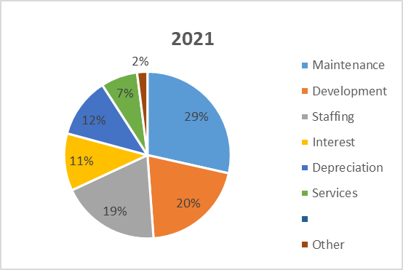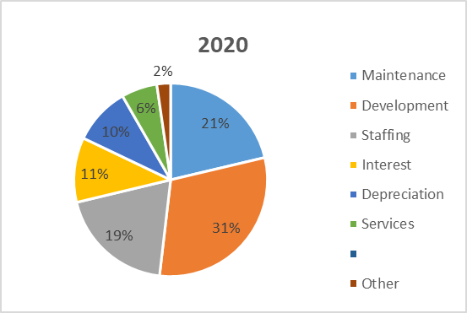

The most significant change in the spend is the level of maintenance spend (up to 29% from 21%) and the level of development spend (down to 20% from 31%). This is a combination of maintenance spend increasing from £5.9m to £6.7m and development spend falling from £8.5m to £4.8m.

Development spend was impacted by the pandemic at the start of the year which delayed works. The spend on maintenance was linked to our stock condition data and the levels of investment approved by Board .

**Performance against Targets**

Target achieved or exceeded

Achievement of target delayed

Target not met

|  |  |  |  |  |
| --- | --- | --- | --- | --- |
| **Strategic Objective** | **Metric/Projects** | **2020/21 Target** | **2020/21 Performance** |  |
| **Customers** | Carry out Institute of Customer Service (ICS) survey of tenants | First survey in 2020/21 | ICS survey carried out in the year and score of 82.9 for customer satisfaction compared favourably to a peer median of 75.3 |  |
| % customer satisfaction with repairs service | 92% | Achieved satisfaction of 90% |  |
| £ of Social value delivered | £2.8m | £5.2m of social value delivered |  |
| % customer satisfaction with overall service | 92% | Performance of 90% - the quality of the repairs service during the year impacted this metric |  |
| % of tenancy turnover | 12% | Performance of 10.2% - this metric has been impacted by the lockdowns during the year |  |
| **Growth** | Number of units delivered (overall) | 76 | 72 units delivered in the year |  |
| Number of supported housing units delivered | 5 units per year | 6 units delivered as part of the Move on Fund programme |  |
| **Culture** | Retain IIP Platinum accreditation | Formal assessment in September 2020/21 | Retained IIP Platinum status with improved scores in all areas |  |
| **Profile and Reputation** | Retain G1/V1 ratings | Assessed annually | Retained G1/V1 rating in December 2020 |  |
| **Resources** | Deliver operating efficiencies (including procurement savings) | £125k | £300k delivered – see section below on efficiency for more details. |  |
| % of time lost to sickness | 3% | 1.52%. |  |
| Increase the borrowing capacity of the Group | Refinancing Project to be completed by November 2020 | Project completed in November 2020 and resulted in significant increase in borrowing capacity |  |
| **Technology and Digitisation** | % of customers accessing online services | 55% | 59% of customers registered on My North Star |  |
| % of customers reporting repairs through My North Star self-service portal | 20% | We had 12% of our customer report repairs through My North Star |  |
| **Governance** | Consolidation of Group structure | Part of the Refinancing Project which will be completed by November 2020 | Consolidation of the Group completed in November 2020 as part of the refinancing project |  |

Areas outside of target are:

Repairs Service & Overall Customer Satisfaction

During the Pandemic and Lockdown our contractors have faced challenges with labour resources, the reliability of sub-contractors, access to materials and high levels of turnover within administrative teams. This affected their performance. Staff have worked with our contractors to improve the service and satisfaction has risen to 93% as at April 2021.

Feedback from customers highlighted a strong link between effective repairs services and levels of satisfaction overall. To improve the repairs service, we:

* Held fortnightly meetings at a senior level with contractors to develop and monitor the agreed action plan for service improvement.
* Commenced a review into “a repairs service for the future” which will involve engagement with staff, customers and other stakeholders.

New Homes

Progress was delayed due to the pandemic as outlined above.

% Repairs Reported on My North Star

For three months during the first lockdown we limited repairs to emergency jobs only. This restricted customers’ ability to report repairs using the portal.   
  
**2020/21 Savings Delivered**

The delivery of savings is key in both the 2020/21 budget and the 30 year business plan. The budget includes savings targets and these also feature in the business plan. The budget included a savings target of £125k.

Some of the key savings made in 2020/21 are captured below:

|  |  |
| --- | --- |
| **Saving** | **Value** |
| Vacant posts were held whilst we reviewed roles and functions. | **£318k** |
| We worked with our tax advisors to maximise the VAT recovery of the refinancing project costs. | **£100k** |
| We used in house resources to deliver training, design corporate artwork and coordinate thank you gifts for all staff. | **£10k** |
| We continue to benefit from the investment into the development of staff who can facilitate organisational and people development, reducing the need for external consultants. | **£40k** |
| The procurement of new contracts delivered savings – most of these were on maintenance compliance contracts. | **£119k** |

**Reinvestment Activities**

Strong financial management enables us to outperform the budget. As a result, there have been a number of reinvestments made during 2020/21 and most of these have been in response to COVID-19 to minimise its impact on customers and the business:

* Sightcall, an investment of **£18k**, allowed tenants to share videos of their property to ensure the accurate diagnosis of repairs.
* We invested over **£20k** in equipment to allow staff to work from home providing ICT kit and furniture where needed.
* We spent **£40k** on developing a new electronic invoice processing module. As well as streamlining the invoice approval process and providing a more robust control environment, this will save around **£5k** a year on paper and printing costs.
* We provided our front line staff and in particular our supported housing with PPE to protect them and customers – we spent over **£22k** on PPE.
* Additional funding to support organisations working in our communities. Our investment increase from an average of £247k for the last three years to just over **£280k** in 2020/21.

**Efficiencies**

These are improvements or changes which may not directly impact or reduce costs but do free up staff time or resources. This report highlights a range of areas where the changes to a process or new ways of working will have delivered efficiencies meaning that staff can focus on providing additional support or services to customers:

* New ways of remote working were introduced for staff and customers. Microsoft TEAMS allowed staff to stay connected while working from home.
* Housing staff introduced a remote property letting process utilising Docusign to enable customers to digitally sign documents.
* Staff also used videos to complete remote property viewings – this created a much more flexible and simpler process for potential tenants to view properties.
* Sightcall allowed property surveyors to diagnose repairs without visiting a property – this reduced travel time and resulted in a simpler process.
* The digitisation of back office processes such as rent refunds and invoice processing made the processes simpler and quicker for staff to request and administer.

**Community Investment and Generating Social Value**

We care about the people and communities we serve. It’s a key strategic choice to invest in our communities, enabling a broader approach to value which considers the social, financial and economic impacts of work in our communities, this helps protect our assets.

North Star operate in some of the most challenging and disadvantaged parts of the country. Official figures show Middlesbrough and Hartlepool in the top ten most deprived local authority areas in the UK. Middlesbrough has the highest proportion of income deprived households and 41% of children living in poverty.

During the year we invested **£230k** (6% of our net surplus) to a range of local projects engaging and empowering our customers. This included **£56k** for the community investment programme, **£31k** for tenant participation and scrutiny and **£143k** for staffing. This year our social value work reached and benefitted **7,312** people, generated **£54k** of funding and supported **31** different projects.

North Star measures and [reports](https://www.northstarhg.co.uk/about-north-star/corporate-information/social-value-reports/) on the impact of community investment using a suite of measures and outcomes which mix qualitative (views and opinions) and quantitative (facts and figures). In 2020/21 we have delivered £5.2m of social value across our business. This figure is made up of:

* £4m generated by community investment projects.
* £256k generated by tenant connection activity.
* £614k generated by planned maintenance activity*.
* £300k generated by positive move on from supported accommodation*

*estimated figure based on last year’s adjusted for impact of COVID-19.

Each year we deliver more social value through our procurement activity, involving contractors delivering work placements, labour days for local community projects, cash donations and resources in-kind. This year COVID-19 has restricted our ability to deliver this activity.

**Asset Management**

Our property portfolio is diverse. Our Asset Management Strategy sets out how we manage, maintain, dispose and review the performance of our stock. We hold stock condition data on over 96% of our assets which is externally validated every two years. This robust data helps to inform our strategic decisions relating to stock investment. Our investment programme is developed to combine works to both minimise disruption for customers and achieve efficiencies for North Star through procurement.

During 2020/21 we spent **£2.4m** to improve 695 homes and their surrounding environments. Although the profile of our expenditure altered due to the Pandemic, we were still able to deliver a comprehensive planned investment programme, with customer satisfaction at 96%, exceeding our internal target of 95%. Active asset management and planned investment is not only vital to ensuring homes meet customer expectations, it is also key to reducing responsive repairs.

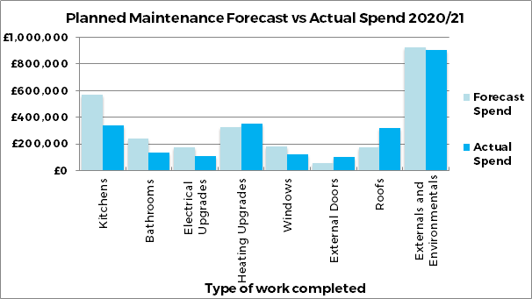

We have started to develop our approach to the decarbonisation of our stock and know that this will require significant investment. We hold energy performance information on 40% of our housing stock and have used this as a baseline for our modelling. We aim to improve the energy efficiency of all of our housing to EPC C by 2028 at a cost of £5m ahead of the Government’s target of 2030 which was approved by Board January 2021. We aim to maximise our investment by accessing grant subsidy and to work collaboratively with Local Authorities and peers to achieve efficiencies for North Star through joint research and procurement.

Return on Assets

Our asset management model is based on reviewing the Net Present Value (NPV) for asset groups and individual properties. We use this data to understand more about the financial performance of our stock, and as a tool to help us maximise the efficiency of the stock when making asset management decisions. We refresh annually and review the top and bottom performing asset groups. We identify actions to enhance financial performance where possible and/or help sustain our stock and estates moving forward. Recent examples of our approach have included:

* Conversion of two bed sits in Barnard Castle into a 2 bedroom house.
* The conversion of former Darlington Housing Association Office into two 2 bedroom apartments.
* Reviewed sustainability issues with our stock in Gresham, with a report planned to be shared with Board in September 2021.

Our Neighbourhoods

In addition to evaluating the financial performance of our stock, we also analyse the performance of our stock in the context of the neighbourhoods and communities we operate in. On an annual basis we refresh our neighbourhood sustainability matrix, which assesses the overall health of the estates and communities. Having a more detailed understanding of the value of our assets (financial, social and environmental) provides us with good and transparent data to help us support our strategic asset management decisions. A recent example of this is our review of the Gresham stock.

We work in challenging communities which experience high levels of deprivation with socio economic problems. We are committed to these communities and see our investment as helping to sustain and enhance the areas and lives of our tenants and neighbourhoods. Investment will reflect local circumstances, with health and stability of communities playing a key role in our investment and management decisions.

Our Neighbourhood Sustainability Tool assesses the health of our communities following analysis of a range of socio economic indicators, including levels of anti-social behaviour (ASB), crime and housing demand. The following chart combines financial and neighbourhood sustainability data.

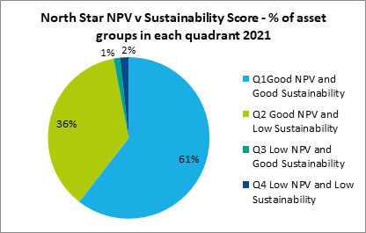

Most of our stock is performing well financially. The chart highlights that we have stock in deprived areas although the Net Present Value is strong. We will continue to review our lower performing asset groups to understand more and look to improve the financial performance where possible.

**Key Projects**

1. **Review of our Treasury and Governance Arrangements**

This project involved the consolidation of the Group and refinancing. The project had VFM at its heart and there were four objectives that were all achieved:

|  |  |
| --- | --- |
| **Objective** | **Outcome** |
| To increase the development of new units | Increased from 290 to 590 units over the next eight years |
| To improve the financial resilience of North Star | Reduced refinancing, covenant and interest rate risk plus strong performance on stress testing in Business Plan |
| To simplify governance and funding structures | Now a single entity with only four funders |
| To deliver Value for Money | Business Plan net surplus increased from £85m (April 20) to £179m (April 21) |

A key area of the project was optimising the security of North Star and the new funding delivers this. The asset cover ratios on the new funding are 105% (Economic in Use Value) and 115% (Market Value subject to Tenancy). We also have significant liquidity in place (in excess of £40m at 31st March 2021) and have under £30m of unencumbered stock.

Our financial strength was also validated by a credit rating of ‘A – with a stable outlook’ that we received from Standard and Poors.

1. **ICT Infrastructure**

During 2020/21 we tendered for a new ICT infrastructure partner. The procurement of the new infrastructure was support by a specialist ICT consultant and the tender specification had a strong focus on delivering VFM. This included long term cost certainty, flexibility to increase our server capacity to meet the future needs of the business and a specific requirement for our new partner to deliver efficiencies over the period of the contract.

Our move to the new infrastructure will provided some significant benefits with minimal cost increases:

* Enhanced security with Multi Factor Authentication.
* The implementation of Office 365 which will support collaborative working and help drive digitisation.
* Access to Sharepoint so we can host and develop our intranet and website without the need for external consultants.
* A cloud based infrastructure providing resilience and flexibility.
* It provides a foundation for the future digital aspirations of North Star.

There is now a three year ICT strategy in place to ensure the delivery of the Technology and Digitisation strategic objective.

**EFFECTIVENESS**

VFM is also about the effectiveness of the organisations as well as the economy and efficiency. The following demonstrates how we capture effectiveness of delivering our strategic objectives across North Star.

**Customers**

We capture customer satisfaction in two ways, through transactional surveys with customers after specific interactions or services and secondly through an annual survey focusing on customer’s perception of North Star.

**Transactional Customer Satisfaction – (HouseMark)**

We capture independently gathered satisfaction data covering a number of service areas. This is benchmarked against other housing providers using the HouseMark scheme. The performance is set out below including actions for key areas of underperformance:

|  |  |  |  |  |  |  |
| --- | --- | --- | --- | --- | --- | --- |
| **Satisfaction with** | **North Star Housing Group** | | | | |  |
| **2018/19** | **2019/20** | **Target 2020/21** | **2020/21** | **HouseMark Benchmark Quartile Position** | **Actions** |
| The overall service | 87.5% | 92.3% | 92% | 90% | Upper | Review requirements for the repairs service of the future with staff and customers |
| Maintenance | 89% | 88.3% | 92% | 90% | Median |
| Quality of their home | 85% | 87.8% | 90% | 84% | Median | Complete a review this area to better understand poor performance. |
| Value for Money (Rent) | 92.6% | 94.4% | 95% | 92% | Upper | Improve communication and consultation with customers on rent and service charge setting |
| Complaint management | 90.3% | 65.9% | 93% | 100% | Upper | None |
| ASB management | 100% | 96% | 100% | 100% | Upper | None |

We have been working with our contractors to improve our repairs service and know that we need to improve communication and reduce the number of missed appointments.

The satisfaction with the quality of the home is 84%. We need to do some specific work with our customers to understand the poor performance in this area. One of our customer commitments is:

*“We will provide you with a safe home that is in good repair. If we don’t, we will make it easy for you to tell us and make sure you understand how we will make it right.”*

The quality of the home to forms part of this and TVSP will also be scrutinising this area in 2021/22 as part of their programme of reviews.

At 31st March 2021 92% of customers felt that their rent provided VFM, this has reduced in the last year. We are strengthening communication and consultation with customers on processes relating to rent and service charge setting ahead of the 2022/23 financial year. We know there is a focus in the Social Housing White Paper on VFM and in particular transparency and we will be working with TVSP and our customers to meet these requirements.

**Customer Perception Satisfaction – (Institute of Customer Service)**

Our membership with the Institute of Customer Service (ICS) enables access to leading edge research on the customer experience, connection with customer service innovators operating in a range of sectors and a non-housing sector benchmarking scheme, the [UK customer service index (UKCSI)](https://www.instituteofcustomerservice.com/product/ukcsi-jan-2021/).

Detailed research from ICS the shows a direct correlation between great customer service and the financial performance of an Organisation which can help drive VFM.

540 customers completed a customer perception survey with the ICS this found:

* North Star scored 82.9/100, comparable with the [top 10 organisations](https://lp.instituteofcustomerservice.com/hubfs/UKCSI%20July%202020/ICS%20UKCSI%20Exec%20Summary_July%202020%206%20July-v4.pdf) operating nationwide.
* Customers highlighted the ethics, customer experience and ethos of the organisation as strengths.
* Customers identified complaints as an area North Star could improve, specifically the speed, handling and outcomes.

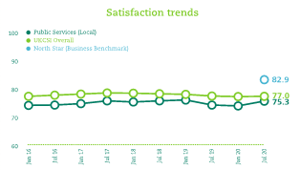 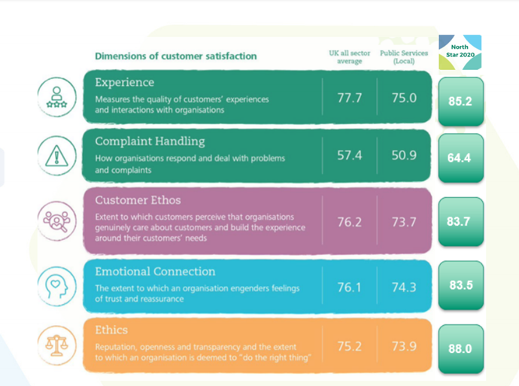

Consequently, customers have been involved in a review of our approach which has:

* Reduced the number of stages in the process to speed up complaints’ resolutions.
* Identified a new approach to enable customers to provide feedback in real-time.
* Provided complaints handling training for staff.
* Introduced more regular complaint reviews to identify learning and improvement.

**Strategic Objectives**

Our other strategic objectives, as set out in section 2.3, were delivered via the Corporate Plan for 2020/21 that was reported to Board in March 2021. Some of the VFM actions were:

* Growth – we accessed funding from the Move on Fund to buy six homes in Middlesbrough
* Culture - We also updated our procurement policy to embed our values and social purpose and ensure this was part of any future procurement.
* Culture - We continued to invest in our staff and culture during 2020/21. We developed our own in house leadership development course – Facilitative Leadership Our Way – and held virtual sessions during the year.
* Culture – We mapped out our contribution to the delivery of the United Nations Development Goals. This captured our contribution from 2018 to these goals

**Performance**

Another measure of effectiveness is the KPI performance and the annual performance for 2020/21 was shared with Board in June 2021.

| **Performance Area** | **2018/19** | **2019/20** | **Target 2020/21** | **2020/21** | **HouseMark**  **Quartile Position** |
| --- | --- | --- | --- | --- | --- |
| Current arrears – General Needs & Older Persons (GN&OP) | 1.94% | 2.29% | 2.75%* | 2.50% | Median |
| Current arrears – Supported | 0.53% | 0.79% | 0.75% | 0.70% | Not available |
| % rent lost through homes being empty (GN&OP) | 1.2% | 0.85% | 1.2%* | 1.02% | Upper |
| % rent lost through homes being empty (Supported) | 1.77% | 3.70% | 4%* | 2.72% | Not available |
| Tenancy turnover rate | 14.2% | 12.9% | 12% | 10.2% | Lower |
| Average number of repairs per property | 3.6 | 3.8 | 3.7 | 3.1 | Median |
| % of appointments kept | 91.3% | 95.8% | 95.0% | 93% | Lower |
| % of gas services completed before expiry date at quarter end | 99.9% | 100% | 100% | 100% | Upper |
| % of time lost to sickness | 3.1% | 3.2% | 3.0% | 1.5% | Not available |

*[*2020/21 target adjusted in light of COVID-19 pandemic]*

During the first lockdown, the Government introduced emergency legislation suspending all but exceptional possession proceedings and extending notice periods given to tenants. Consequently, North Star did not complete any evictions in 2020/21. Research by Shelter has previously identified a cost of c.£7k associated with evicting tenants. Learning from this period is being reviewed and implemented with the intent of sustaining low levels of evictions and robust arrears performance.

Our Welfare Benefit team supported 447 households to increase their income by £715k, of which £128k is direct gains to the rent accounts through back dated housing benefit and discretionary housing payments. This work benefits both customers and North Star.

Our Tenancy turnover reduced from 12.7% to 10.2% whilst strong relet performance supported lower levels of void loss than were anticipated at the outset of the Pandemic.

Our average number of repairs per property has reduced but the main factor has been the impact of the Pandemic. More information on this area is included in the benchmarking section of this report.

The national average absence rate in 2020/21, according to the Office of National Statistics, was 1.8%.

**4. North Star Trends and Comparison to other Housing Associations**

**Benchmarking**

Benchmarking enables us to assess costs and performance against our peers.

There is a time lag to the publication of benchmarking data so the most up to date peer information is for the 2019/20 financial year.

There is a range of information available which can be used to benchmark the performance and costs of North Star. It can identify areas of high cost or poor performance that can be investigated by staff and action taken to improve if required. There can be difficulties in drawing absolute comparisons on benchmarking data. We use benchmarking in the following ways:

**HouseMark**

HouseMark are the leading data and insight company for the UK housing sector. North Star pay an annual fee to be a member and also submit quarterly performance data and annual cost data. HouseMark also collate the Sector Scorecard data. The most recent peer group data is for the 2019/20 financial year.

**RSH Global Accounts**

Every year we are required to submitted financial information to the RSH in the Financial Viability Assessment. All organisations with more than 1,000 units are required to submit this data. The RSH then publishes an annual paper along with the data for all organisations. The 2020 Global Accounts report can be viewed [here](https://northstarhg-uk.azeusconvene.com/jsp/dm/file_download.jsp?DOC_ID=8ACEF9B4-7FB7-4036-BB44-485C67A60D4A&LATEST=Y&PAGE=1).

**RSH VFM Metrics**

As part of the RSH VFM standard organisations are required to publish a set of VFM metrics. This data is then shared for all organisations along with a report. The full report for the 2020 metrics can be viewed [here](https://northstarhg-uk.azeusconvene.com/jsp/dm/file_download.jsp?DOC_ID=7D5BB0C4-7BF8-4FBE-B1ED-CD6A9452AAFD&LATEST=Y&PAGE=1).

**Peer Groups**

Where possible the standard peer group as set out below has been used in the analysis. The standard peer group is taken from organisations in the North East, North West, Yorkshire and Humberside with between 2,500 and 7,500 units with supported housing. However, not all of this peer group submit data onto HouseMark and to ensure there is a sufficient sample size we have used a different peer group for the HouseMark analysis – details of this peer group are shared later in the report.

|  |  |
| --- | --- |
| North Star Housing Group | Leeds Federated HA Ltd |
| Broadacres HA Ltd | Mosscare St. Vincent’s Housing Group Ltd |
| Calico Homes Ltd | Muir Group HA Ltd |
| Community Gateway Association Ltd | South Lakes Housing |
| Connect HA Ltd | South Liverpool Homes Ltd |
| Equity Housing Group Ltd | South Yorkshire HA Ltd |
| Irwell Valley HA Ltd | Southway Housing Trust (Manchester) Ltd |
| ‘Johnnie’ Johnson Housing Trust Ltd | Weaver Vale Housing Trust Ltd |

**RSH VFM Metrics**

The tables below show the performance on the VFM metrics over the last three years. There is also a more detailed section on the Headline Social Housing Cost Per Unit.



There is no peer group data available yet for 2020/21.

**North Star Trend**

The key points to note from the North Star data are:

* The reinvestment metric has reduced in 2021 with less spend on new development as explained earlier in the report.
* The gearing has increased as a result of an increase in funding linked to the refinancing project.
* The refinancing project has also impacted the EBITDA MRI interest cover metric due to the £7m of exit costs. If exit costs are excluded this metric would increase to 252%.

The refinancing project was a strategic decision by Board and as set out in the section above has delivered VFM in a number of ways for North Star.

**North Star v Peer Group Metrics**

The two areas where North Star are not performing as strongly as our peers are:

Reinvestment Metric

North Star are consistently lower than our peers for this metric which captures the level of capital spend on new development and existing properties. The table below shows that this is due to less capital spend on both new development and existing properties in North Star.



Gearing

North Star gearing has increased to 46% compared to a peer median of 40%. The increase in gearing was as a result of the strategic decision with the refinancing project. The median gearing for the sector, as per the global accounts report, is 44%. In addition, the North Star gearing is well within the gearing covenant of 65%. The variance with our peers could be due to a number of reasons but would need further analysis to investigate this.

**The Sector Score Card**

There are also a number of additional metrics that we record and report that are known as the Sector Score Card.

|  |  |  |  |  |  |  |
| --- | --- | --- | --- | --- | --- | --- |
| **Indicator** | **2017/18**  **Actual** | **2018/19**  **Actual** | **2019/20**  **Actual** | **2020/21**  **Draft** | **Trend** | **2019/20**  **Peer** |
| Units Developed | 31 | 63 | 65 | 72 |  | 49 |
| % respondents very/fairly satisfied with the service | 88.9% | 87.5% | 92.3% | 90.0% |  | 87.4% |
| £ invested in communities | £224k | £246k | £249k | £280k |  | £246k |
| Occupancy rate | 98.9% | 98.8% | 98.9% | 99.2% |  | 99.0% |
| Ratio of responsive repairs to planned maintenance | 0.47 | 0.50 | 0.49 | 0.51 |  | 0.61 |
| Rent collected % | 100.6% | 99.1% | 102.0% | 99.6% |  | 99.1% |
| Overheads as a % of adjusted turnover | 11.2% | 12.0% | 10.9% | 10.5% |  | 13.7% |

There are improving trends on four metrics, one relatively static metric and the customer satisfaction and rent collected metrics have negative trends. The rent collected metric was impacted by the timing of housing benefit payments as 2020/21 was a 53 week rent year. The customer satisfaction metric has already been explained earlier in the report.

**Global Accounts**

The RSH publishes annual Global Accounts to provide a financial overview of the housing sector. The data is presented as a headline social housing cost per unit (HSCU), and has Management, Service charge, Maintenance, Major Repairs (including capital maintenance) and Other Social Housing categories. CPU stands for Cost Per Unit.

**North Star v Standard Peers 2019/20**



Although the HSCU is lower than our peers, our management CPU is higher. As the raw data is taken from the statutory accounts of Associations it is hard to drill down any further. Additionally, there is no sector wide approach to the allocation of costs, which makes absolute comparisons difficult. We have carried out further analysis into this by using HouseMark data (which is submitted using a standard approach) and this is included later in the report. This has shown that management costs within North Star are comparable to our peers.

**Three Year Trend**

The graph below shows how the HSCU has changed for North Star and our standard peer group over the last three financial years:

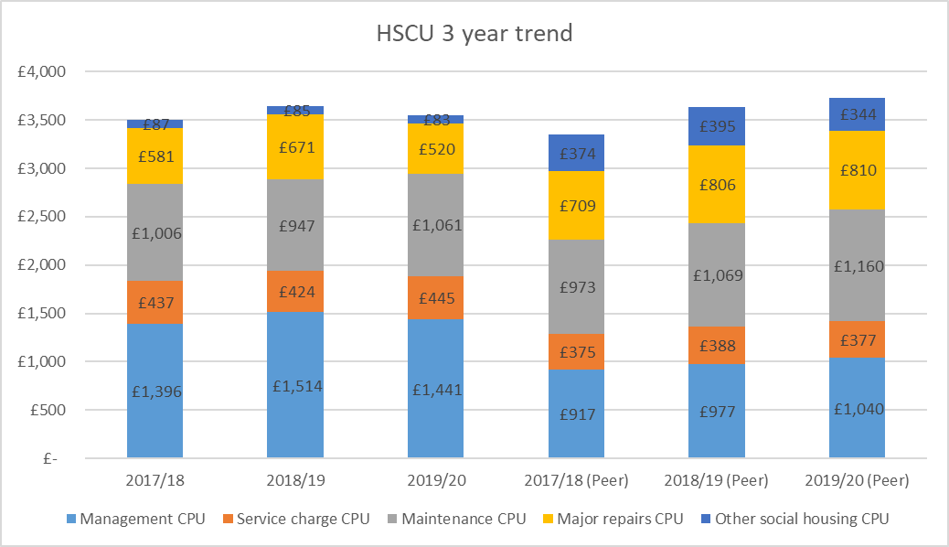

**% Change over Three Years**



The North Star HSCU has increased by 1.2% over the last three years compared to an increase of 11.5% for our peers. Our management CPU has increased by just over 3% and maintenance costs are up by 5.5%. Pay awards are the main driver for the higher management costs. The increase in maintenance is due to an increase in the level of spend on health and safety. Strategic decisions were made in relation to both areas.

Some further context can be provided by reviewing the HSCU compared to the sector median. The sector median HSCU has increased from £3,397 in 2017/18 to £3,835 in 2019/20, an increase of almost 13%. With the exception of other social housing CPU, all other areas have increased by at least 9% and the largest increase is 17% on the maintenance CPU.

The high level nature of the HSCU means that it is hard to drill down to investigate the variances and any further analysis would need organisations to share more detailed financial information. The HouseMark data does allow more detailed analysis to be done and this is set out in the next section.

**HouseMark**

This section of the report focuses on the cost and performance data for the year to 31st March 2020. The peer group used in this analysis is different to the standard peer group – it is made up of organisations with up to 5,000 units in the North East, North West, Yorkshire and Humberside.

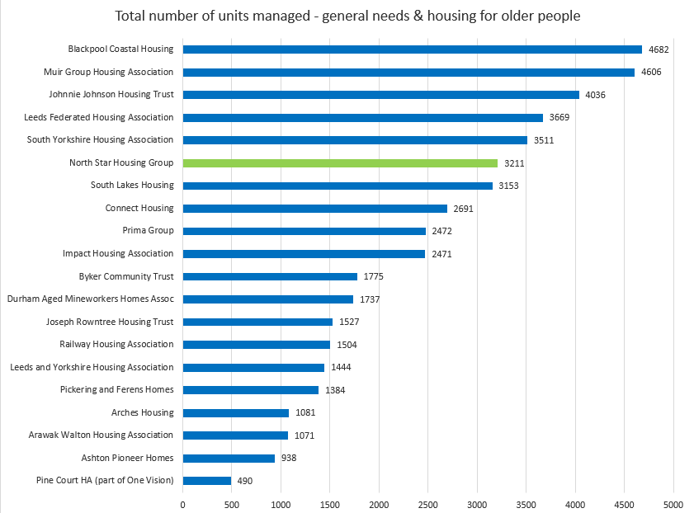

**North Star Performance – high level**

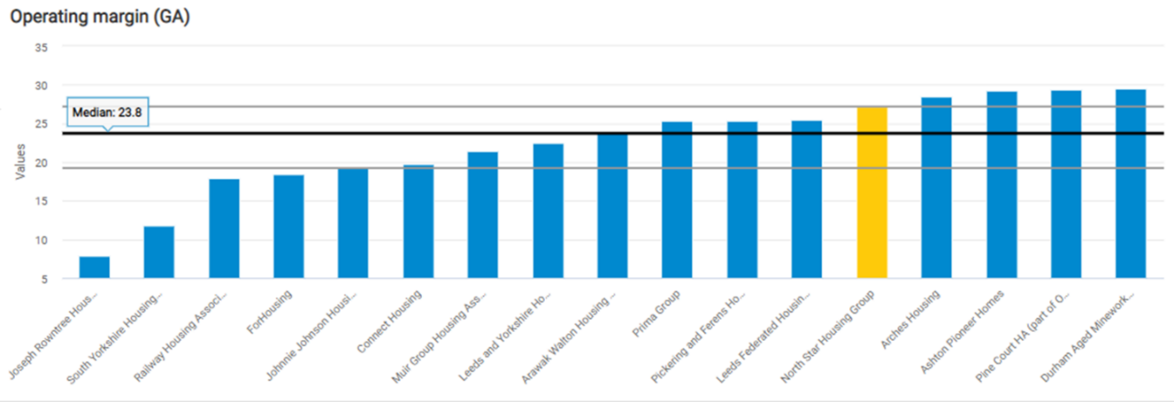

The North Star operating margin is just outside the upper quartile of this peer group demonstrating strong financial performance. The next section set outs benchmarking data on the costs of three key areas of the business – housing management, repairs and overheads.

**Housing Management**

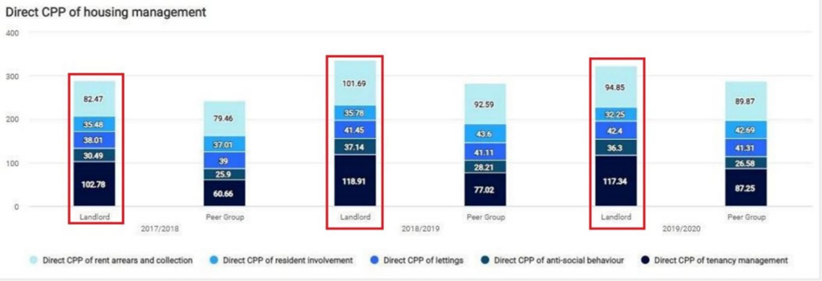

This chart shows that Housing Management costs are higher than our peers. One of the reasons is a higher level of cost on tenancy management which has been the largest element of housing management costs within North Star over the last three years. Within the peer group the largest element has been rent arrears and collection. The total North Star housing management costs have increased by 12% in the last three years compared to an increase of 19% in our peers.

**Responsive Repairs, Voids, Major Works and Cyclical Maintenance**

There is a chart covering responsive repairs and voids and a different chart covers major works and cyclical maintenance. The Direct cost per property for both areas is just outside the top quartile and so compares favourably with our peers.

**Overheads**

Our overhead costs for 2019/20 are just under median level:

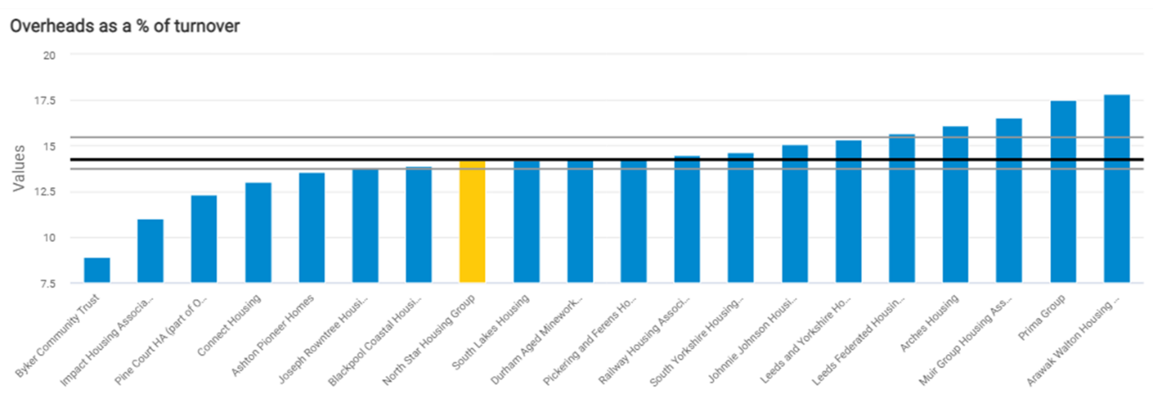

There has been a focus on reducing overhead costs over recent years – this trend can also be seen in the sector score card metrics in the next section.

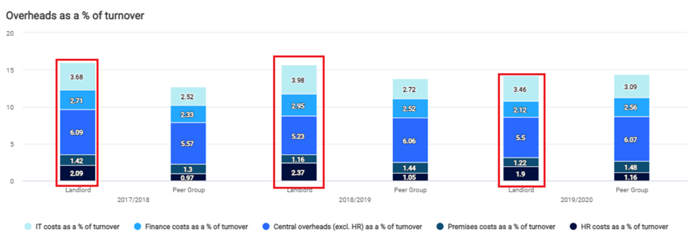

In the last three years, overhead costs have reduced across the five areas used by HouseMark. Our overhead costs are now lower than the peer group and the North Star overhead costs should continue to reduce in 2020/21. The main reduction has been on the salary costs of the ICT, Finance and People Services teams.

The data for all areas show that North Star costs are at, or are under, the median level.

It has not been possible to do any benchmarking on supported housing – the bespoke nature of the services delivered in this area means that data isn’t easily comparable between organisations. We are required to be able to demonstrate value for money under each of the contracts we have with the Local Authorities. There is regular monitoring of our performance and outcomes by the Local Authorities each year.

**Areas of Underperformance**

We have identified a number of areas where North Star are in the bottom quartiles for costs or performance. Some of these are set out below with some further context or actions.

**Community Investment**

Our total Cost Per Property of Community Investment is in the fourth quartile for each of the last three years. These costs include our Welfare Benefits staff, the Communities team and an apportionment of overhead costs. North Star do invest more in our communities and have two dedicated Welfare Benefit Officers to support customers. This investment is a strategic decision by North Star in response to the challenges faced by some of our communities. Our Communities team is key to delivering the social value highlighted earlier in the report.

**Tenancy Turnover**

Although our tenancy turnover has improved over the last three years we still remain in the bottom quartile. Improving tenancy sustainment is one of the corporate plan actions for 2021/22.

**Repairs per Property**

We are above the median for repairs per property. Analysis was done on the repairs per property to see if there was a link between the age of stock and number of repairs. This show there is no clear no correlation between the age of stock and number of repairs within the HouseMark data. However, the Asset team will be working with our contractors in 2021/22 to understand why repairs per property are high and develop an approach to reduce this.

These three areas feature in the VFM actions for 2021/22.

**5.**  **2021/22 and Beyond**

VFM is at the heart of our corporate objectives, budgeting and business planning processes. The budget for 2021/22 is used as Year 1 of our 2021 business plan which included savings of £23.5m across the next 30 years. These savings are incremental over the first five years of the plan and then continue across the remaining 25 years of the plan. The strong value for money culture will be key in ensuring we achieve, and if possible, over deliver on the savings targets set in the 2021/22 budget and 30 year business plan.

**2021/22 Value for Money Targets and Objectives**

The table below captures the Corporate Plan objectives approved by Board in March 2021. Following the analysis outlined in this report, further VFM Targets have been developed. Any items in blue are from the Corporate Plan:

|  |  |  |
| --- | --- | --- |
| **Strategic Objective** | **Action** | **Target** |
| Customers | Implement real-time customer feedback. | Introduce Rant & Rave platform to capture and analyse customer feedback. Return on investment completed August 2021. |
| Customers | Review the supported housing vision | Review will be used to inform continued growth of supported housing |
| Customers | Review priority communities to invest in those most impacted by the pandemic | Review will inform the community investments made in 2021/22 and future years |
| Customers | Review customer satisfaction with ‘quality of their home’ and ‘rent providing VFM’ | New approach for rent and service charge setting to be used for 2022/23 charges.  Report to Board (from TVSP) on the customer commitment review |
| Growth | Develop 50 new homes including 5 supported housing | 50 new units by 31 March 2022 |
| Growth | Review the sustainability of our stock in Gresham | Report to be shared with Board in September 2021 |
| Growth | Conclude the review of the Sir ED Walker opportunity | Regular updates to be provided to Board during 2021/22 |
| Growth | Secure external funding for retrofit works | Target to get grant income of £60k (10% of total budgeted spend on retrofit) |
| Culture | Develop a comprehensive Green Strategy | Strategy to be shared with Board in January 2022 |
| Resources | Deliver procurement savings | £45k |
| Resource**s** | Deliver savings through vacant posts | £80k |
| Resources | Develop a Decent Homes Standard for our existing properties (in accordance with the Government timelines for review). | Approach to be shared with Board as part of Asset Management Strategy in June 2022 |
| Resources | Review the high number of repairs per property to understand any root causes | Report and action plan to be shared with SMT by December 2021 |
| Resources | Improve our tenancy sustainment and reduce our tenancy turnover | Target to reduce tenancy turnover KPI to under 10% |
| Resources | Review of the repairs service | Review will be used to inform future procurement of repairs service |
| Technology | Delivery of the first year of the ICT strategy:   * Integration of Office 365 including Power BI for reporting * Support the Paper Scarce project with the digitisation of back office processes * Implement a new telephony solution | * Use of Power BI for performance reporting to Board and within in the business * Continued reduction in paper use. Target to reduce by 25% * Transition to digital telephony platform |